[Modern DevOps foundations](https://moodle.leedstrinity.net/course/section.php?id=81984) Labs

Lab 01 - Agile Planning and Management using GitHub

Task 1: Create a GitHub repo

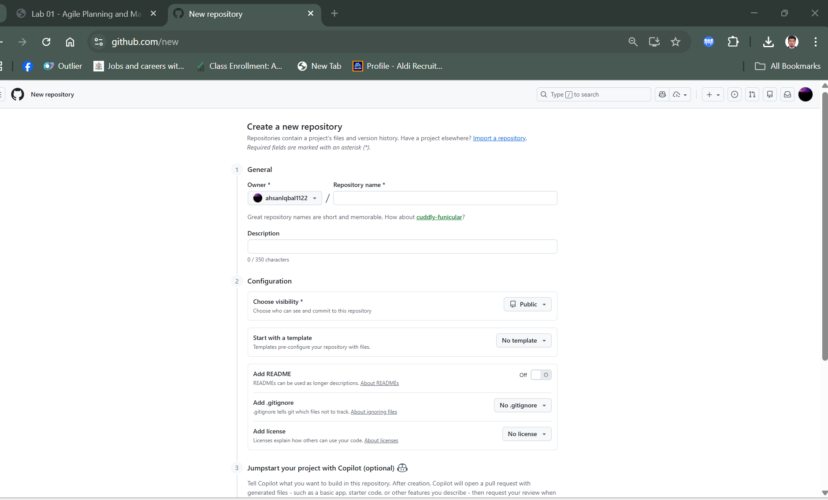

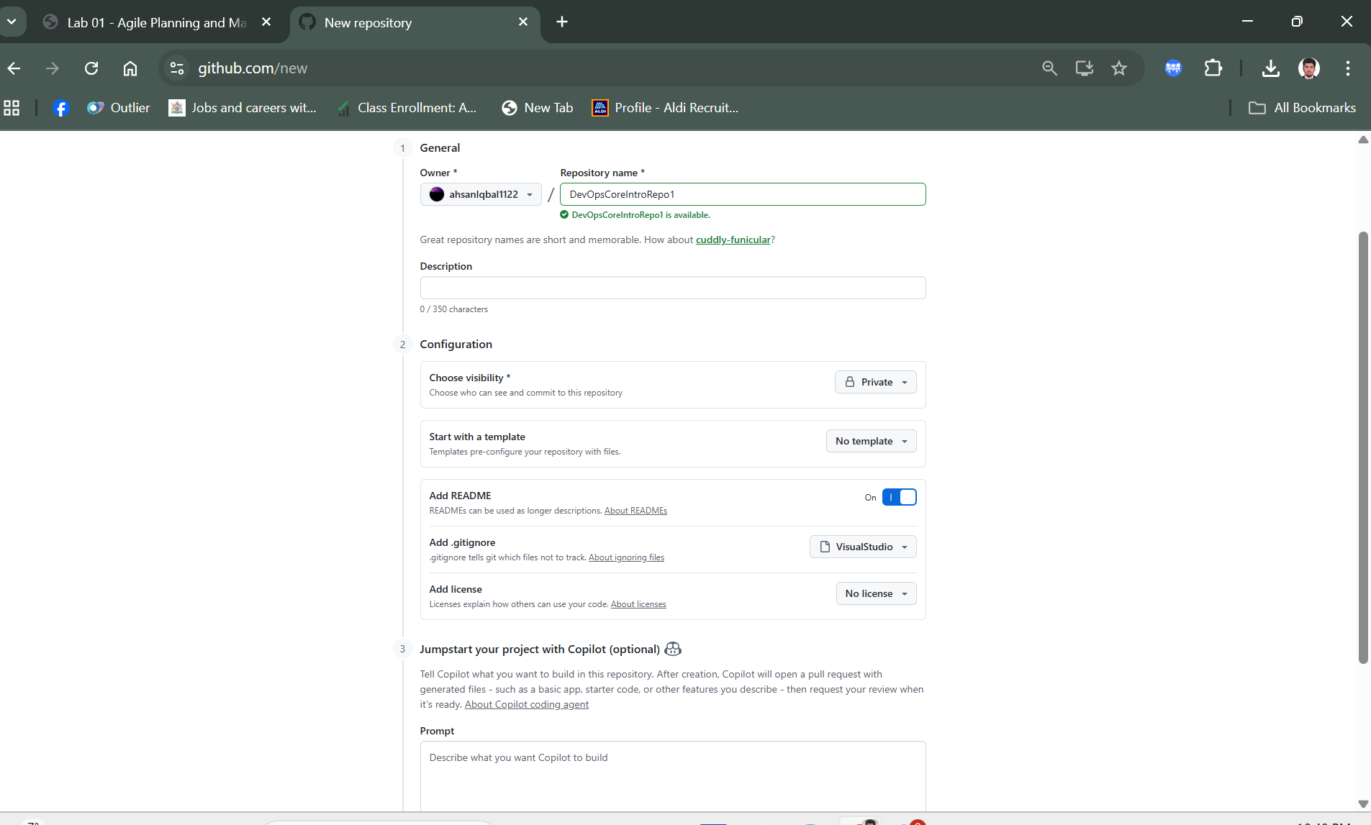

Create Repo

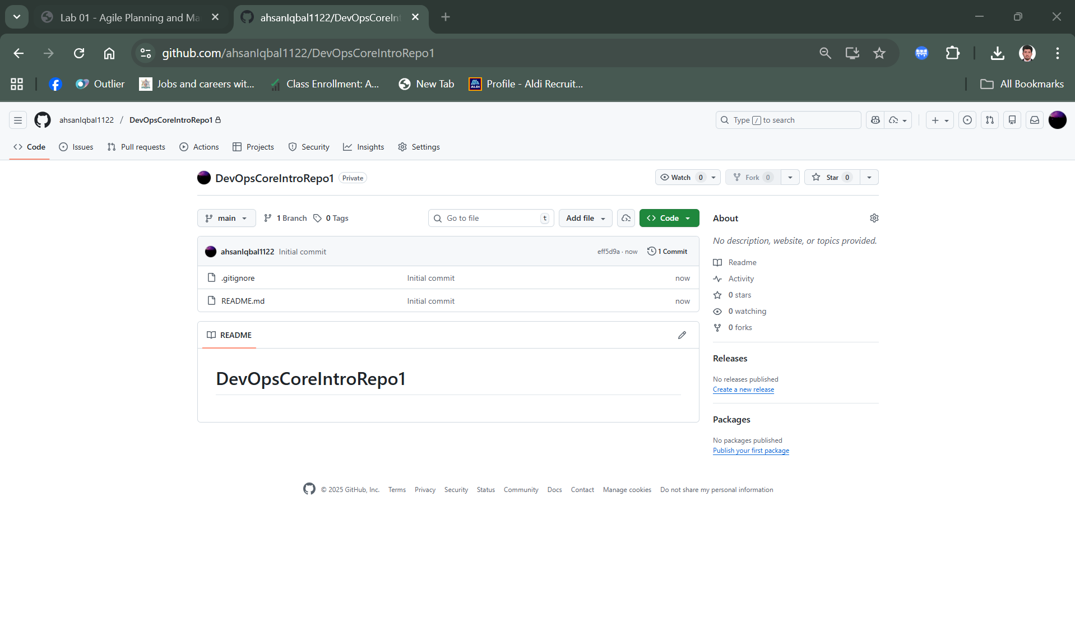

Task 2: Create GitHub milestones and issues

On the **DevOpsCoreIntroRepo** page, select the **Issues** tab.

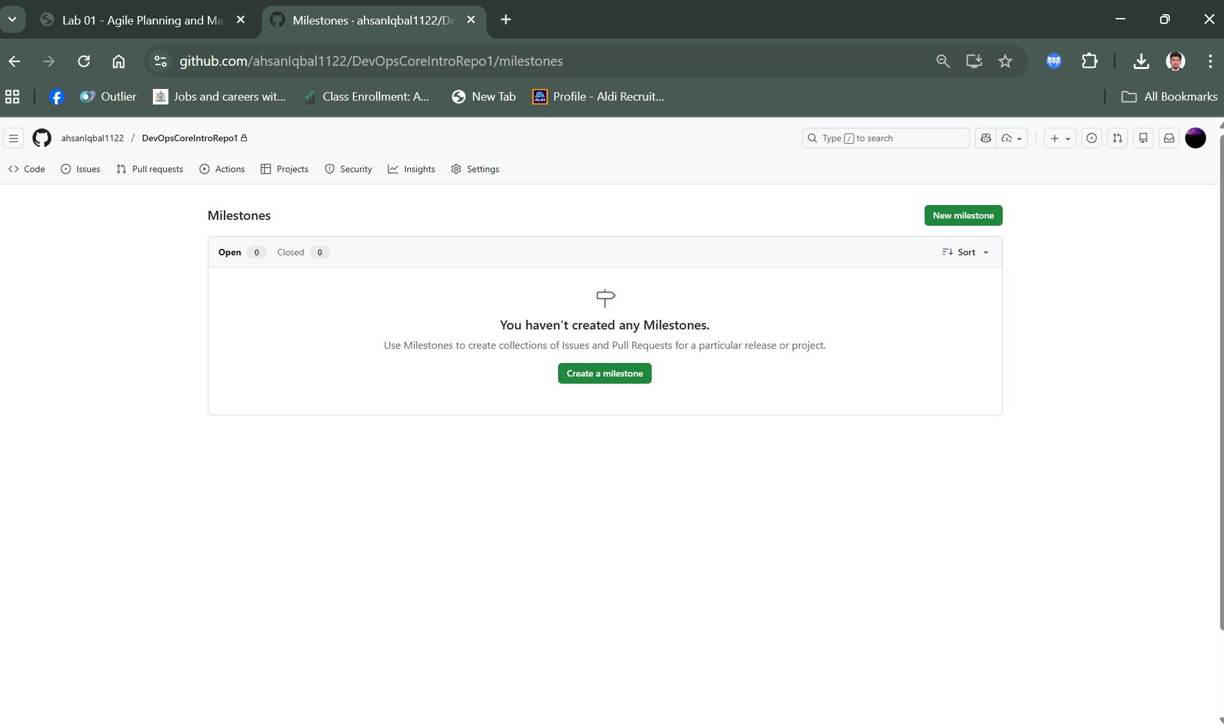

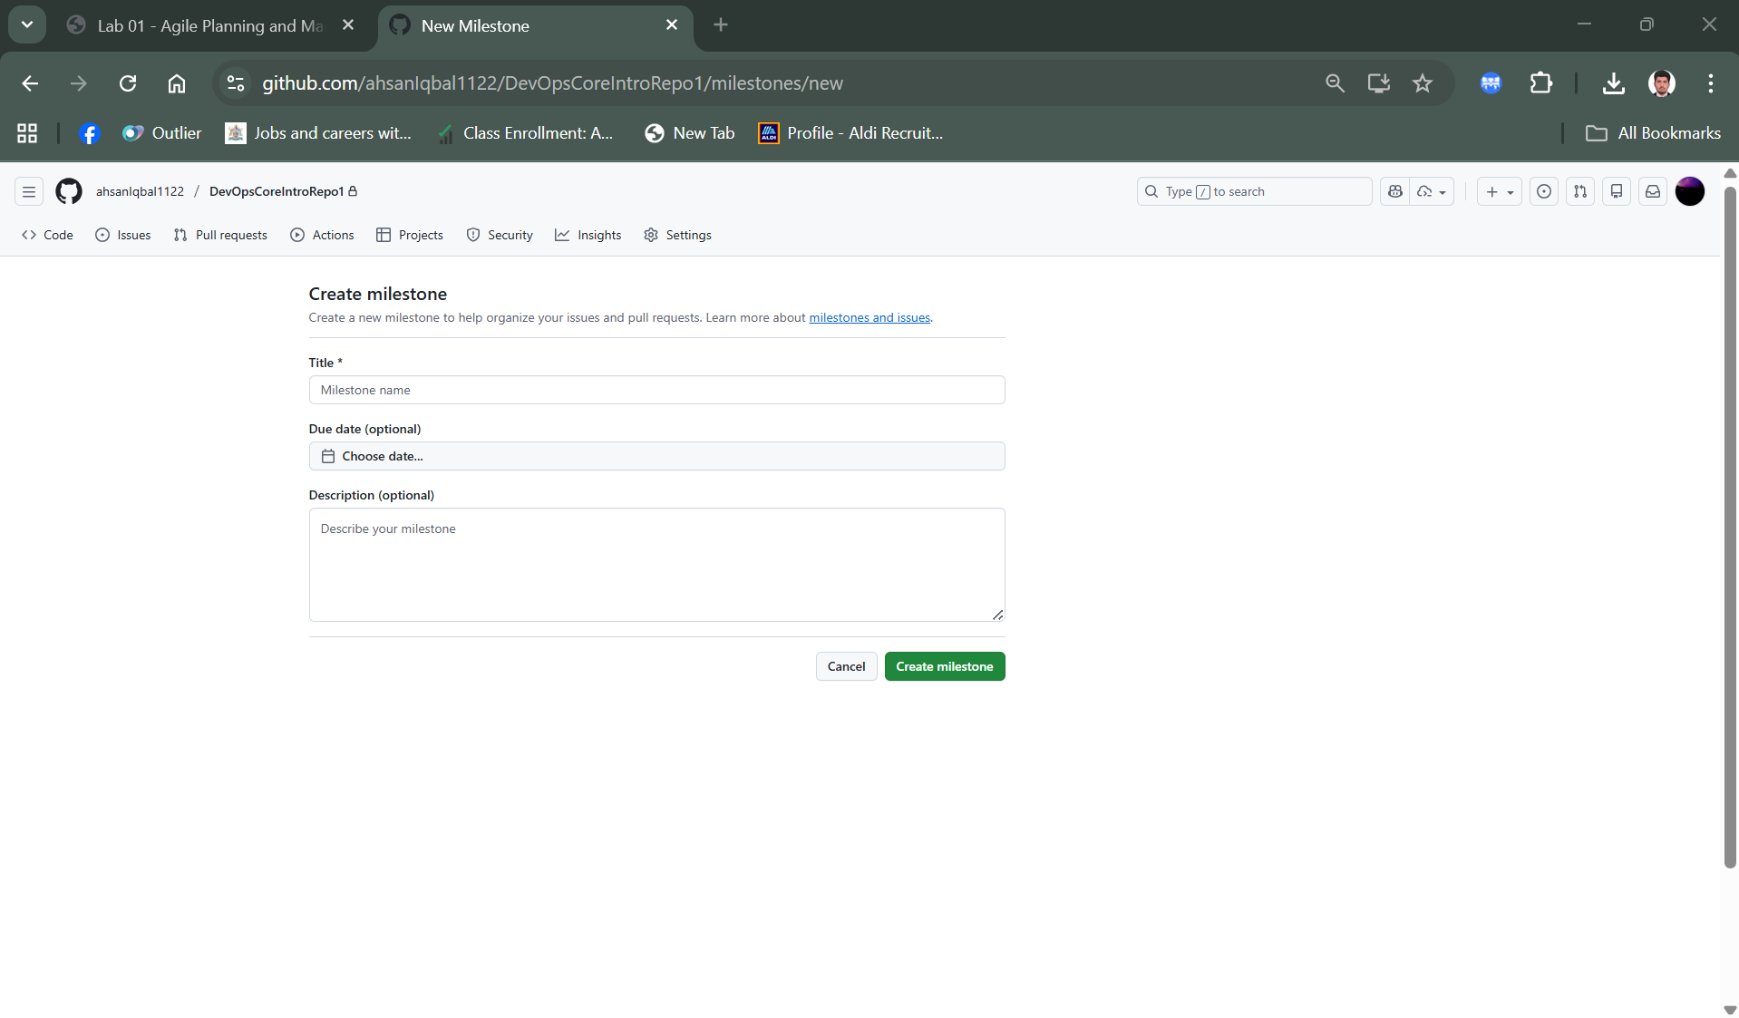

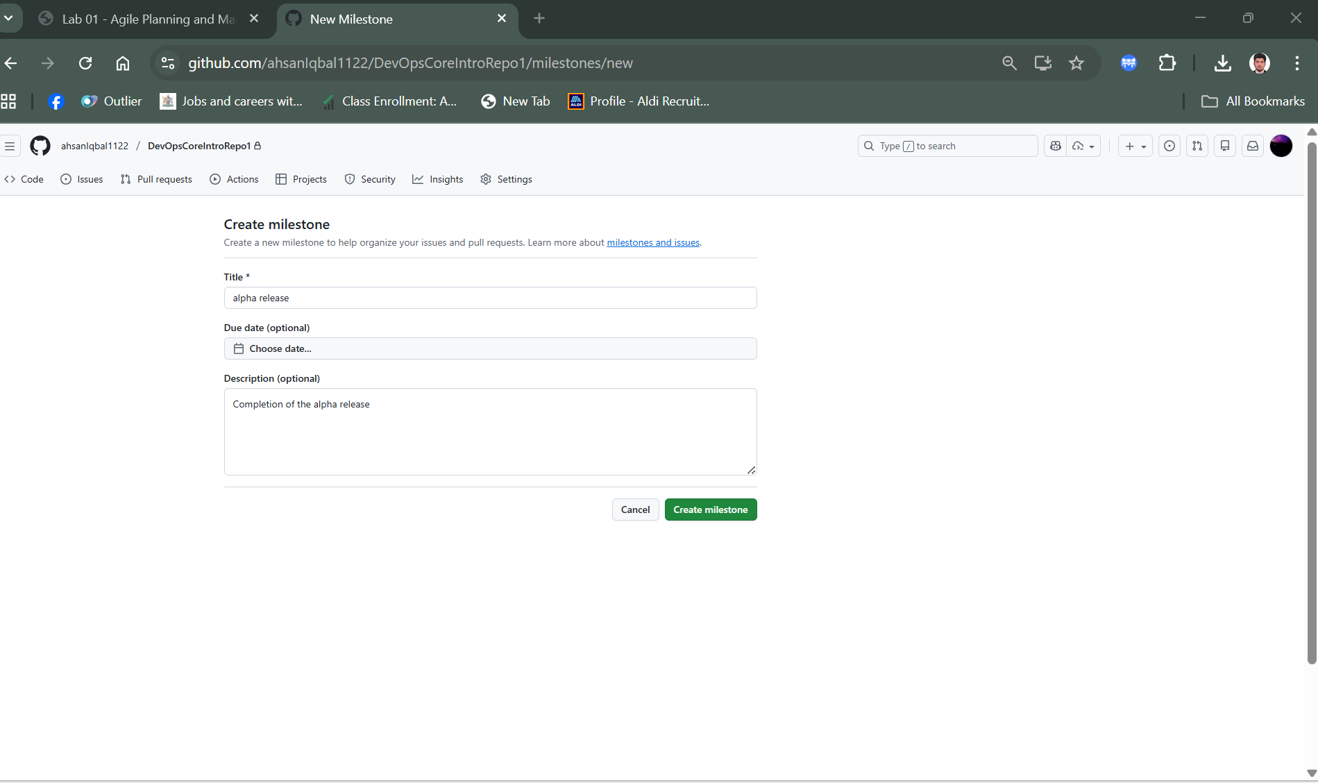

**New milestone**

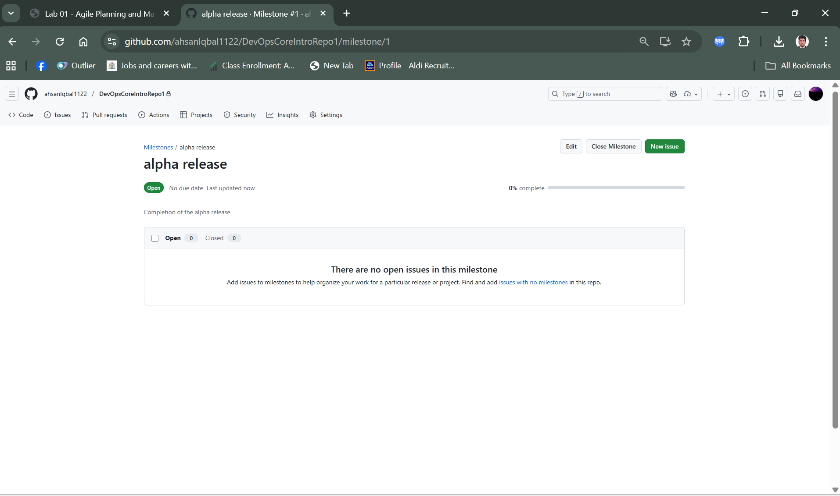

Beta release milestone

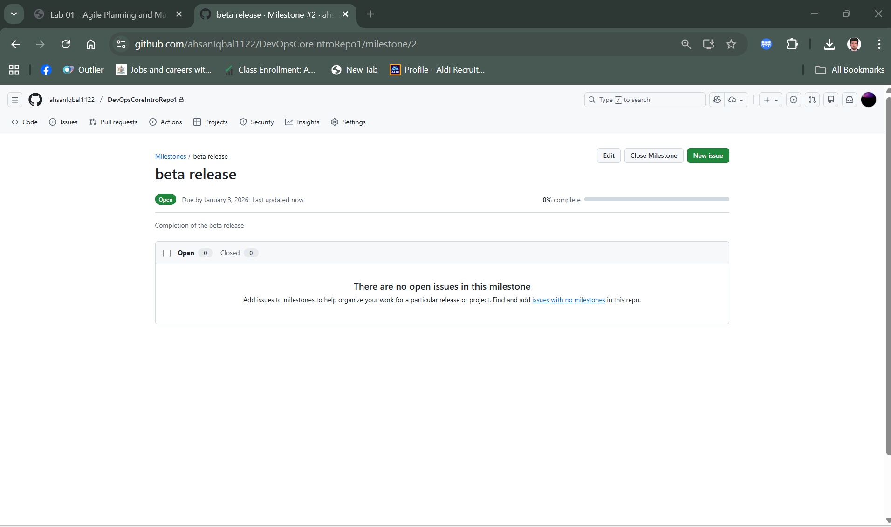

New Issue

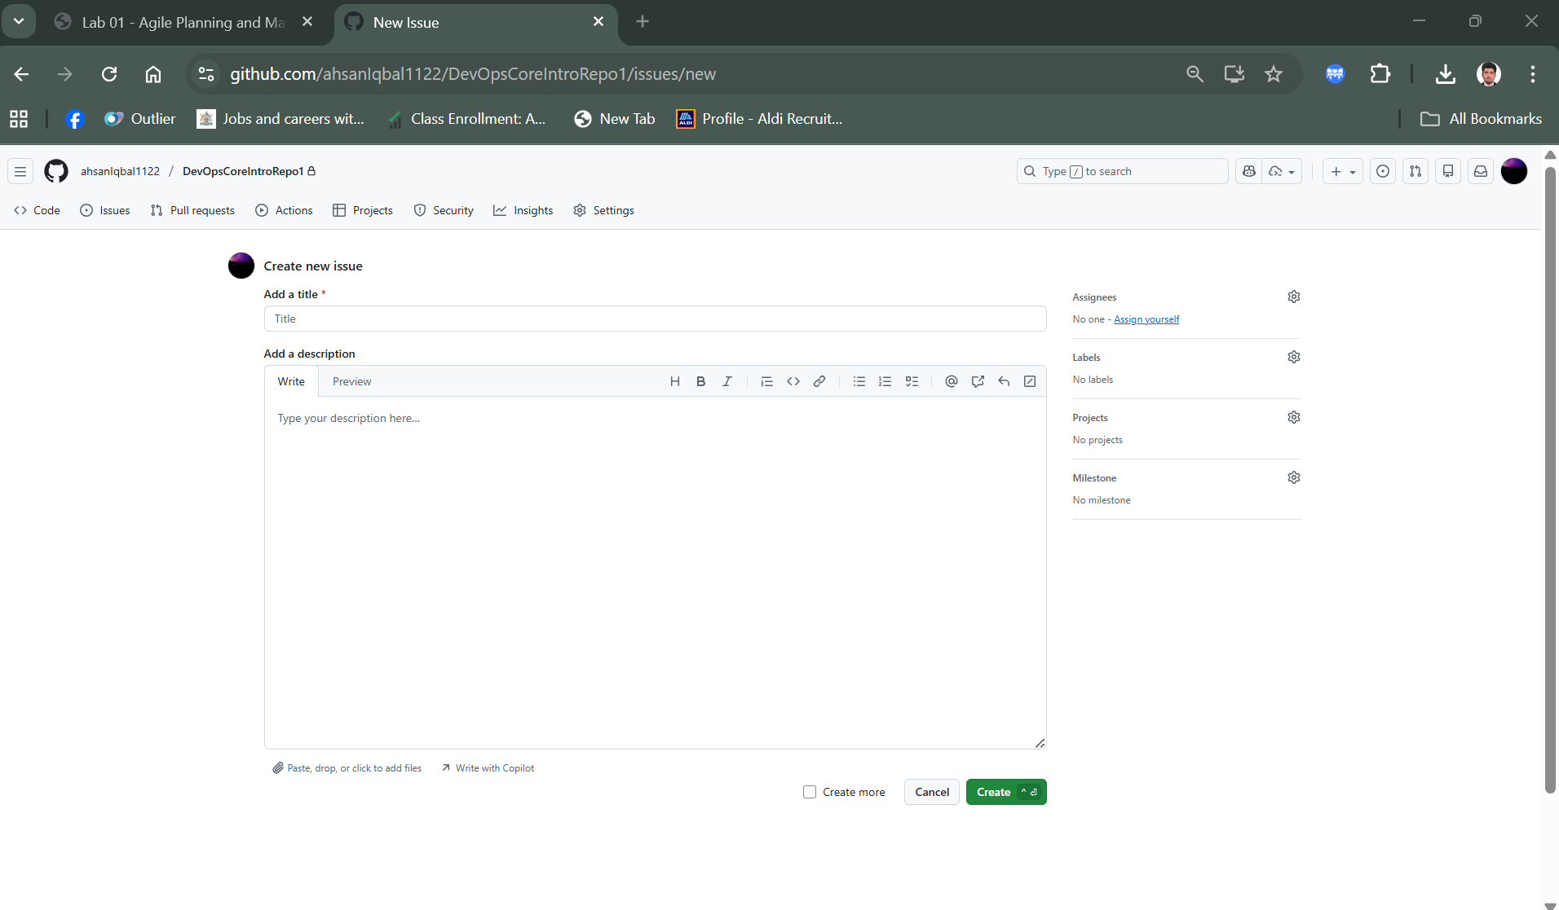

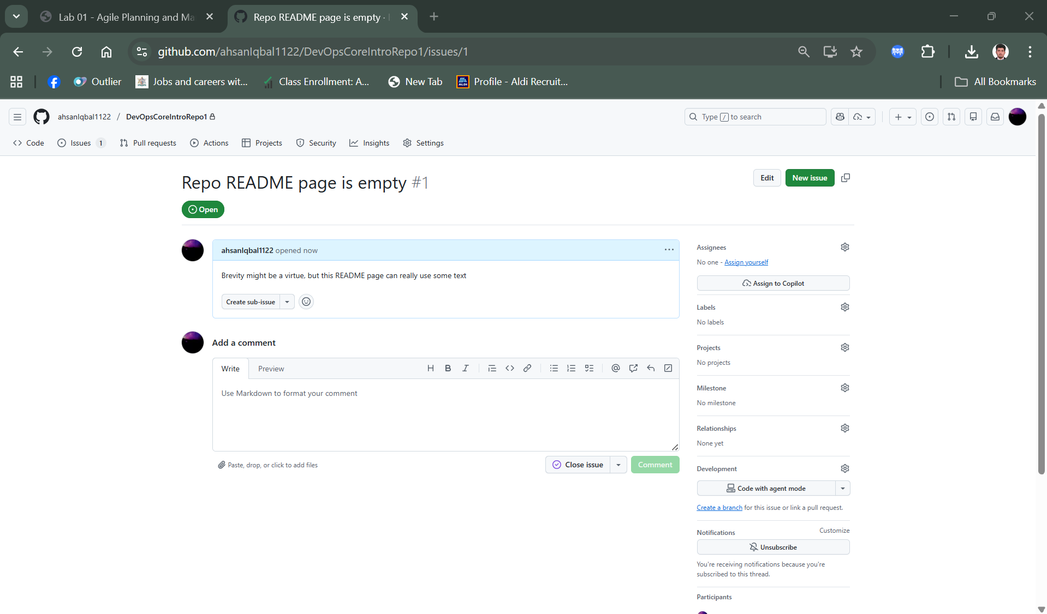

Select the gear icon next to the **Milestone** entry and, in the drop-down list, select **alpha release**.

Select the gear icon next to the **Labels** entry and, in the drop-down list, select **bug**.

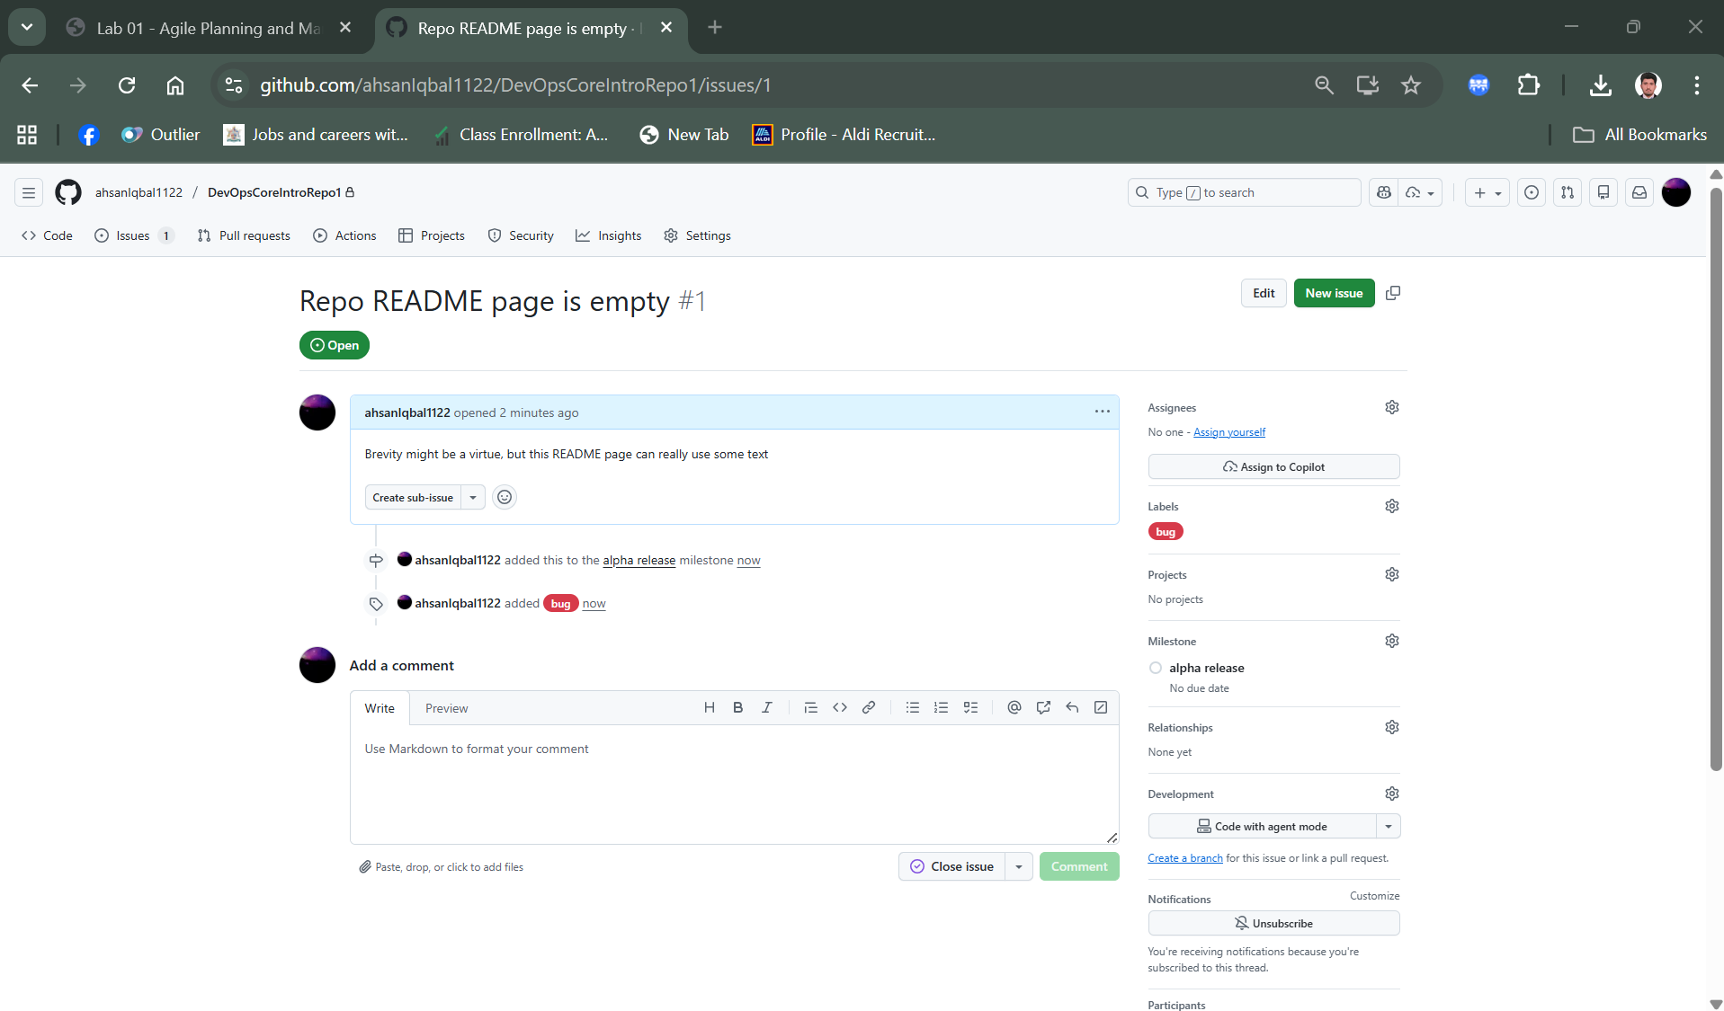

Task 3: Create a GitHub project

Create new github project

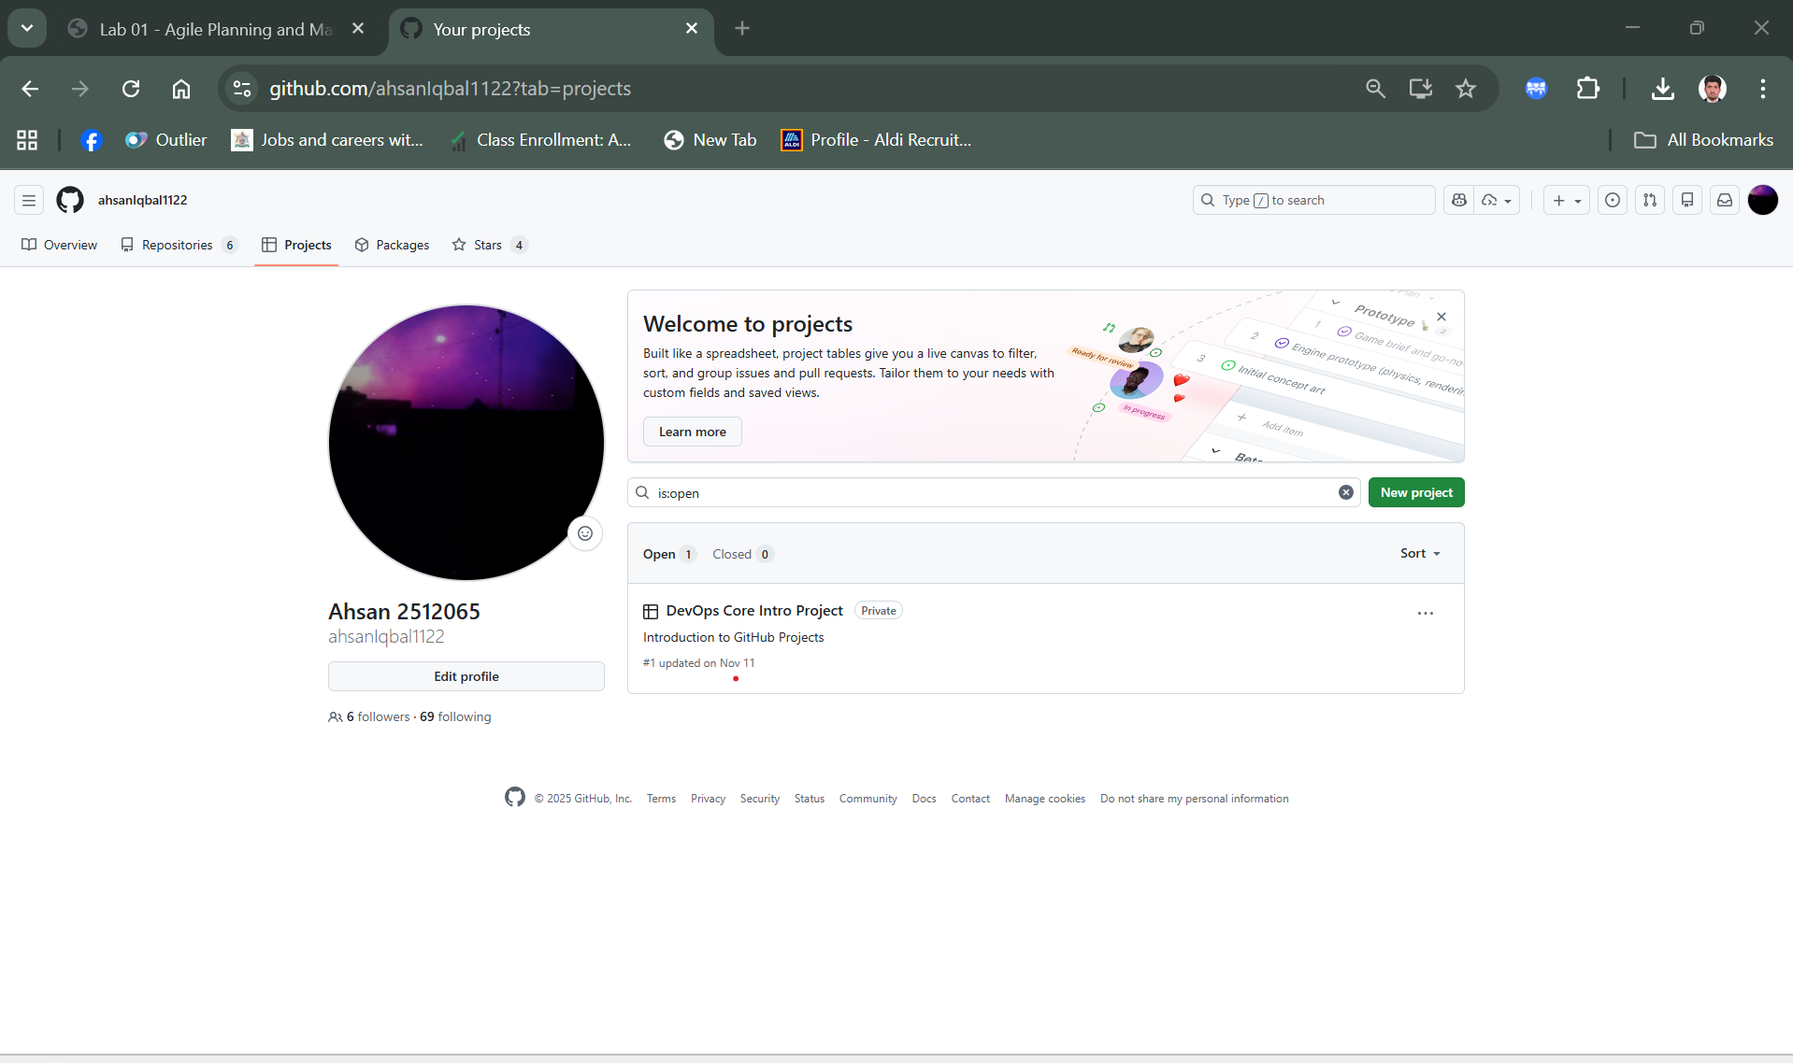

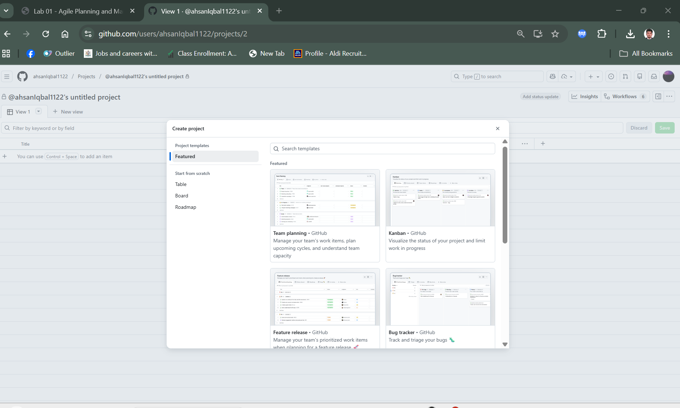

Create project Successfully

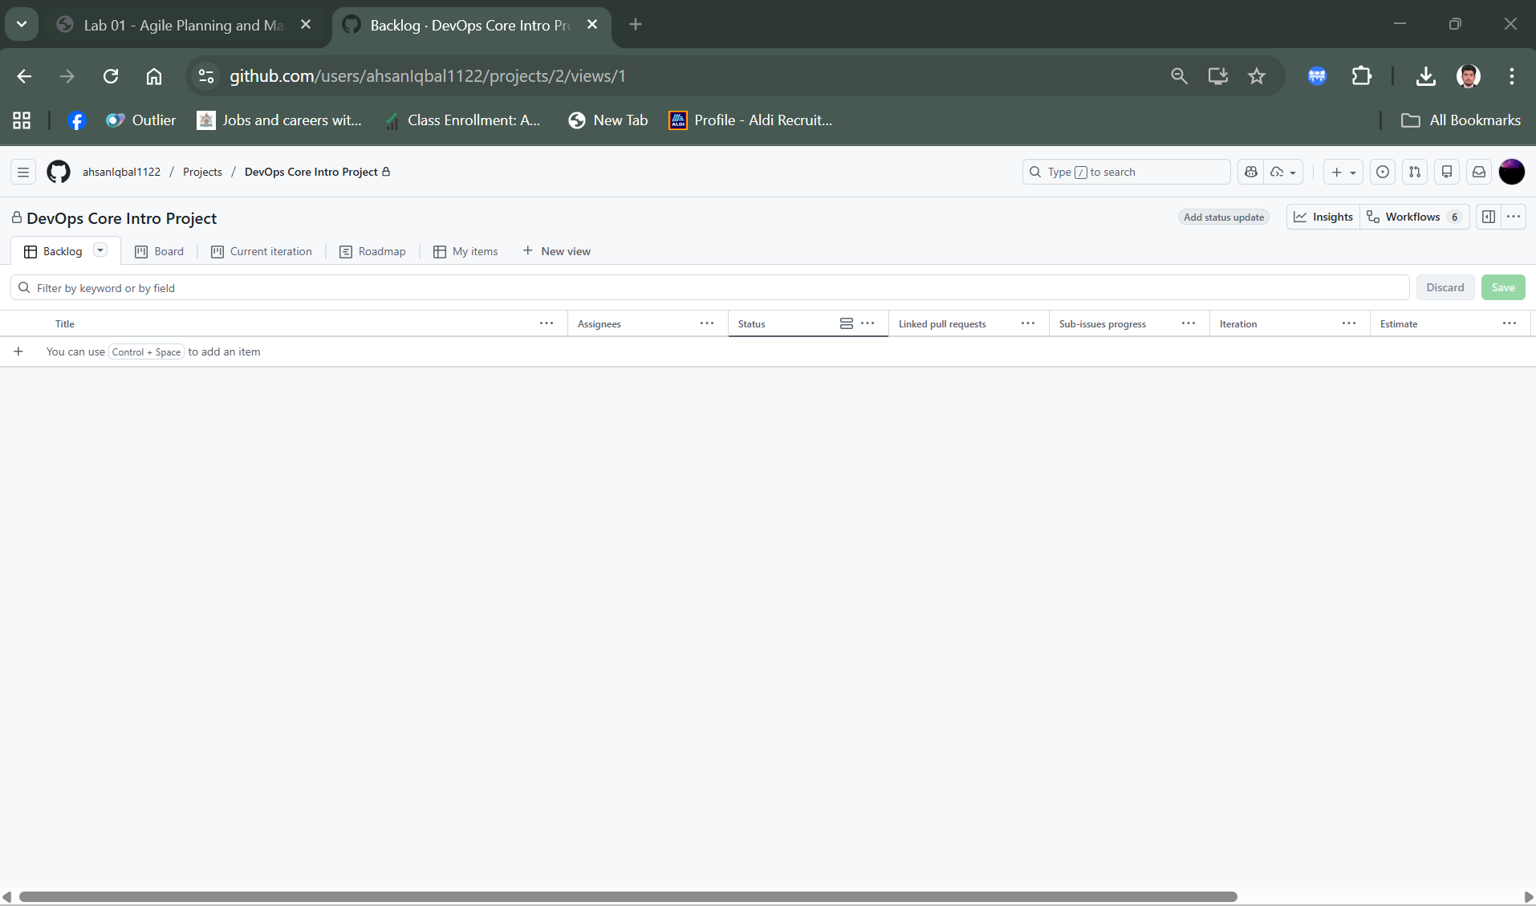

Project name and readme

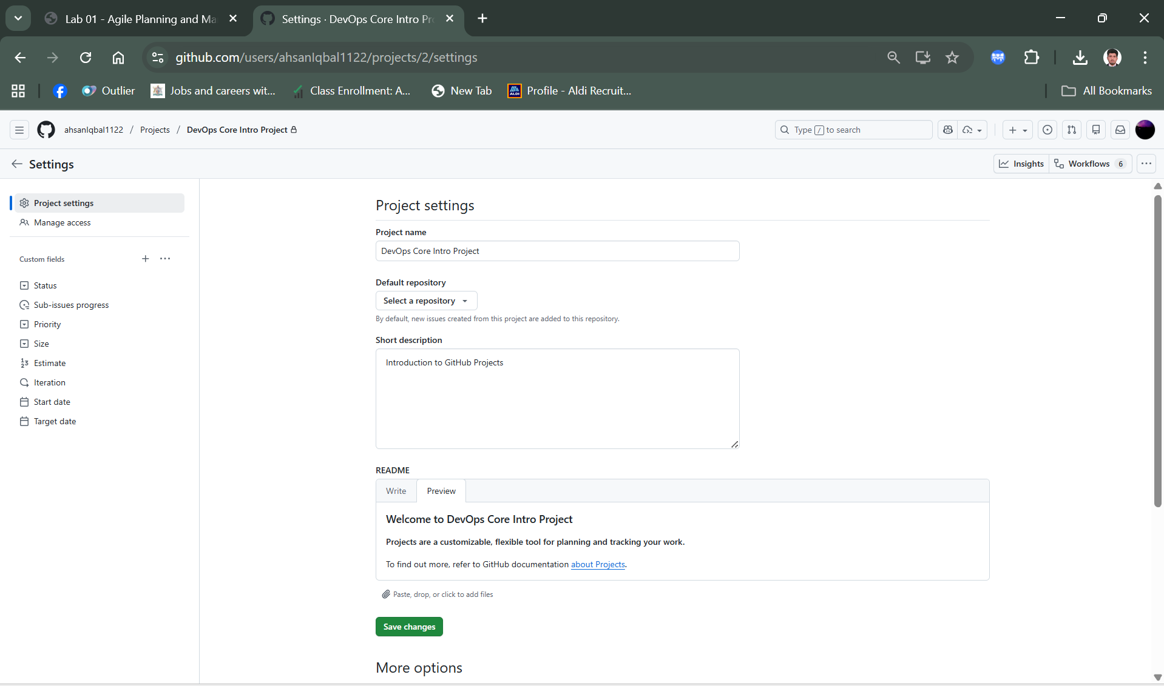

Manage access to the project

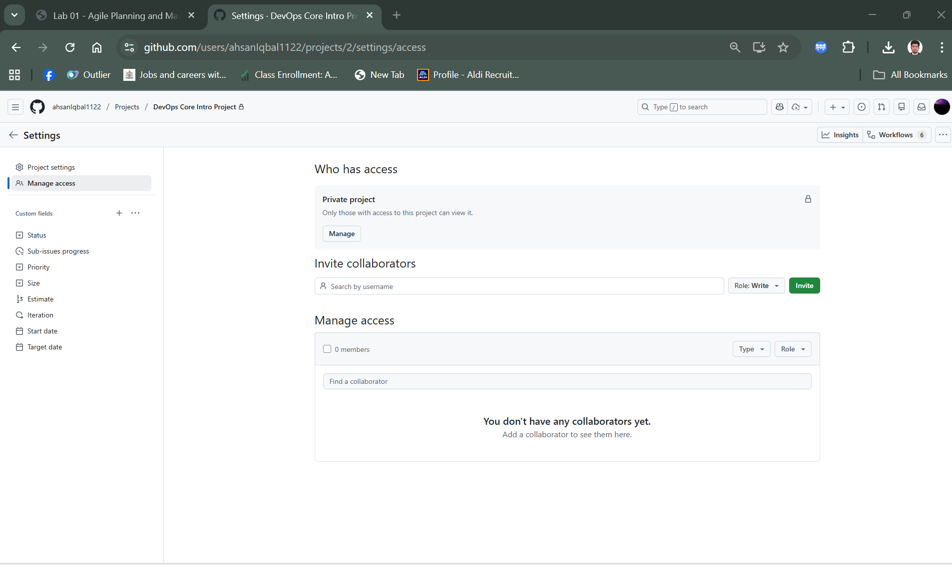

**Task 4: Create a GitHub project board**

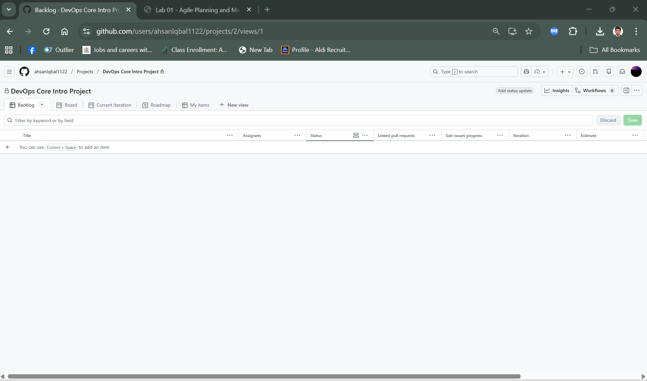

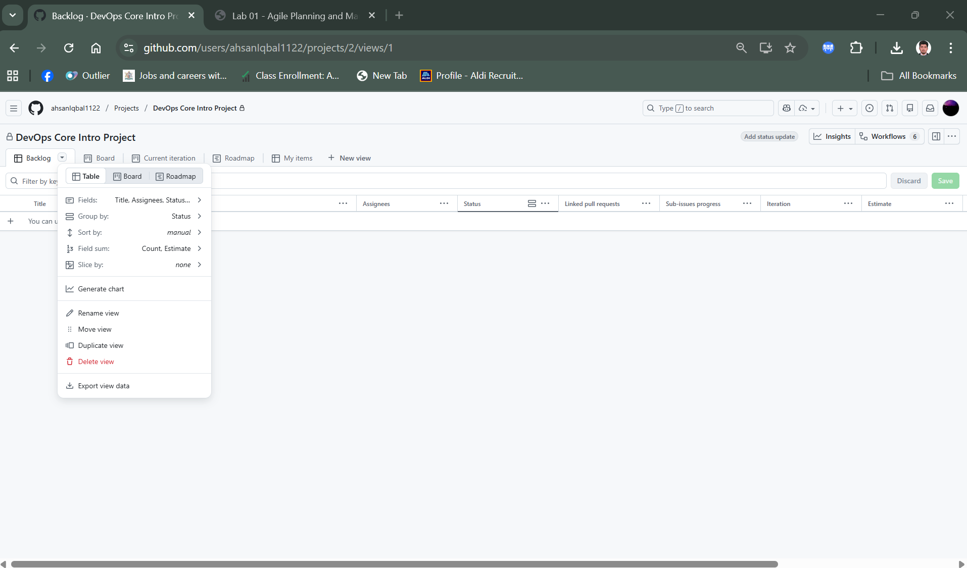

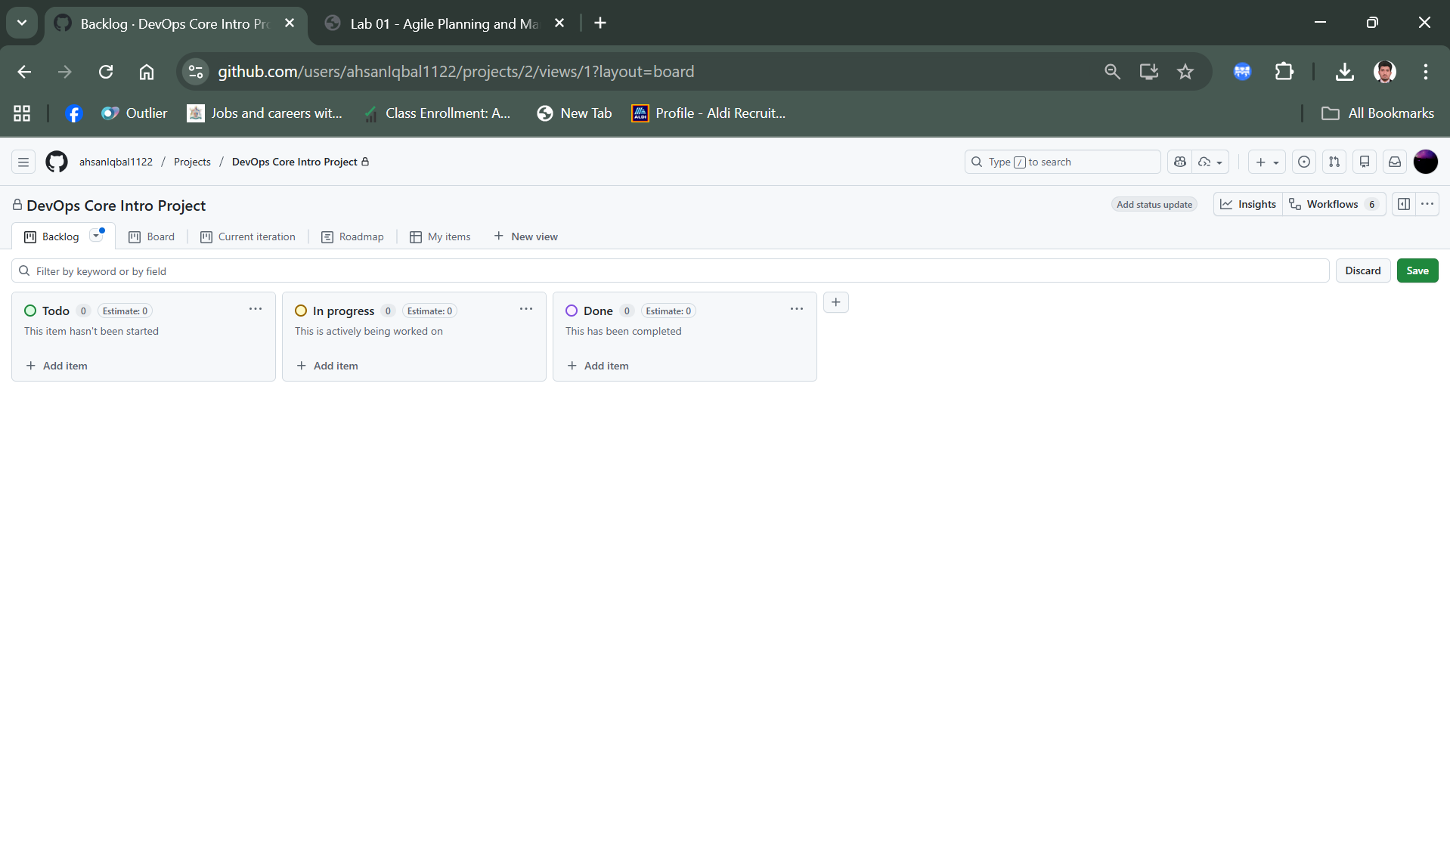

To add an extra column, select the **+** icon to the right of the **Done** column and then select **+ New Column**.

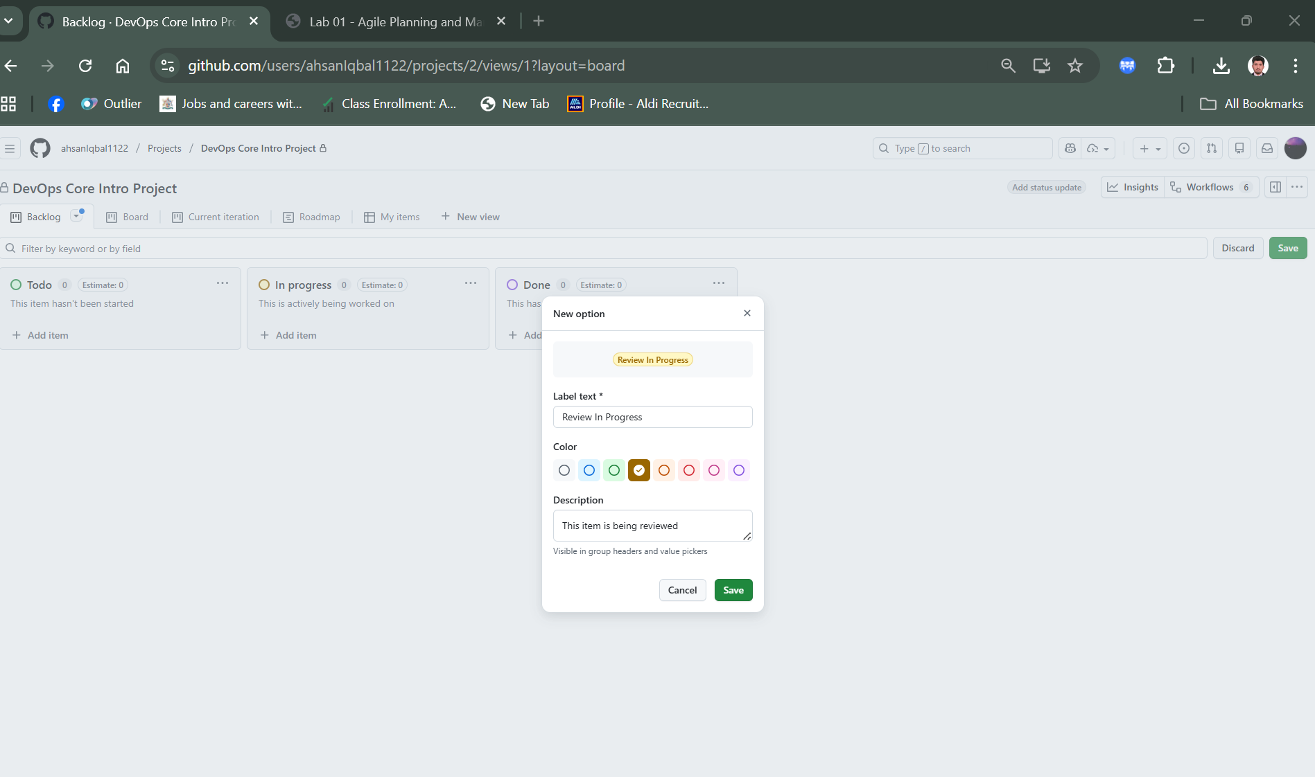

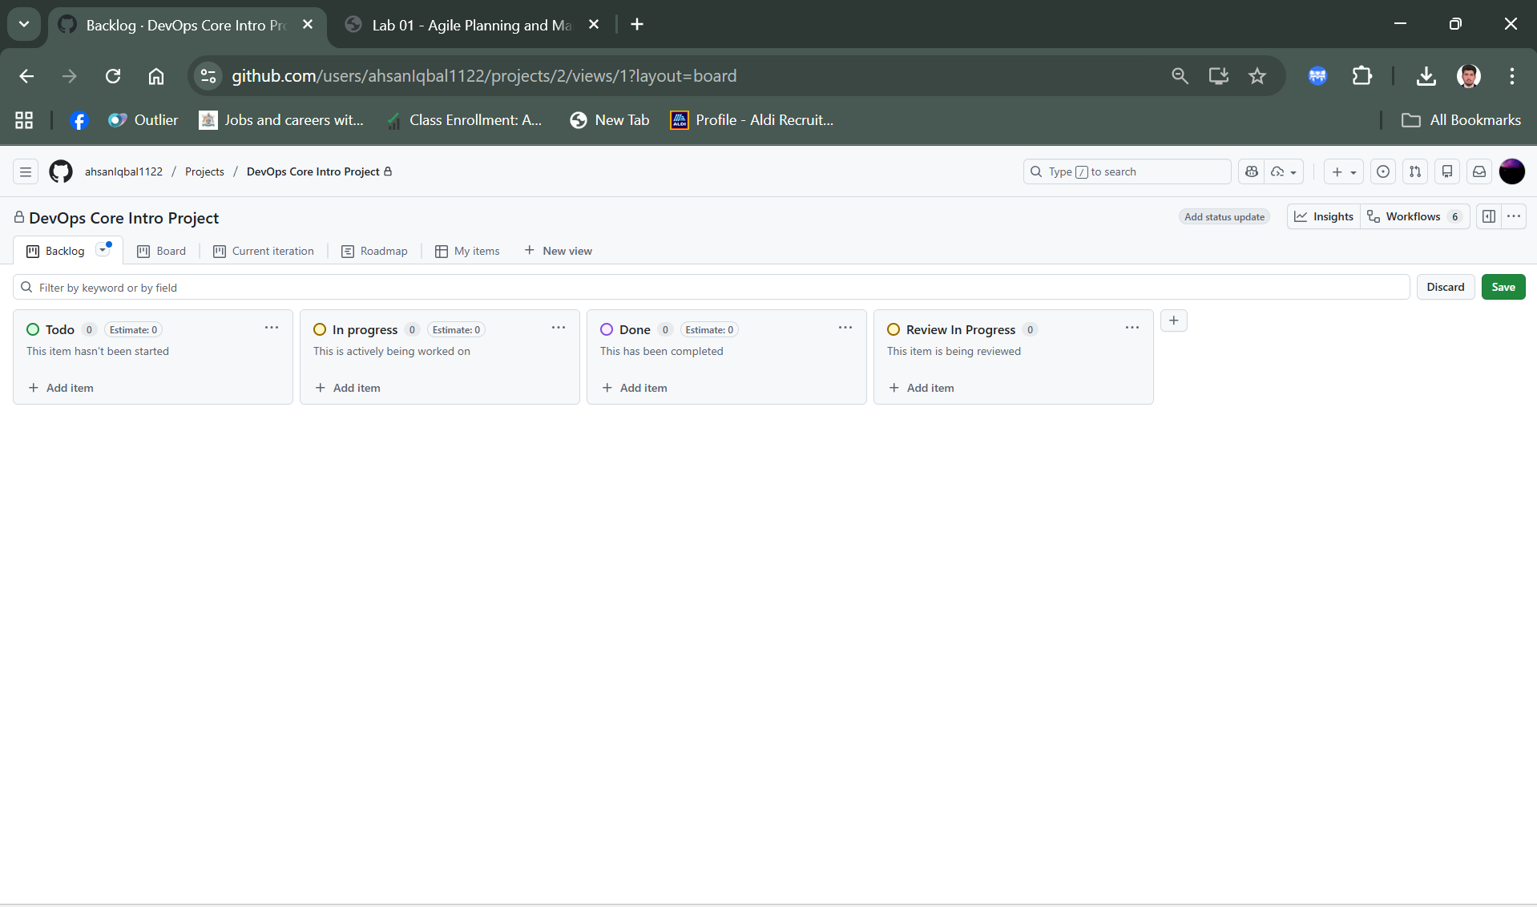

**Exercise 2: Create and manage project board items**

**Task 1: Add a draft item**

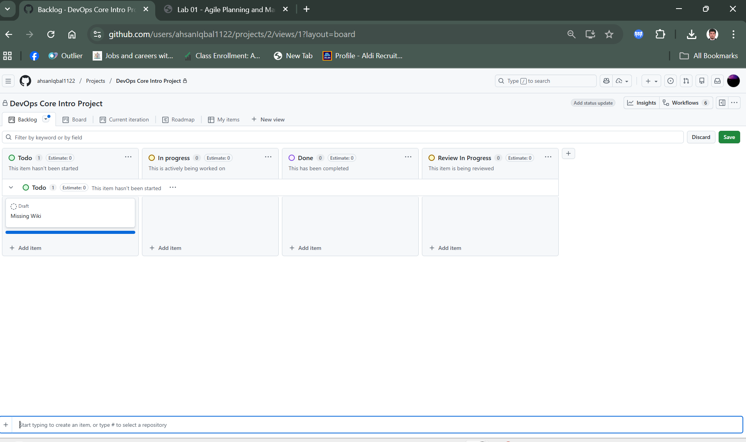

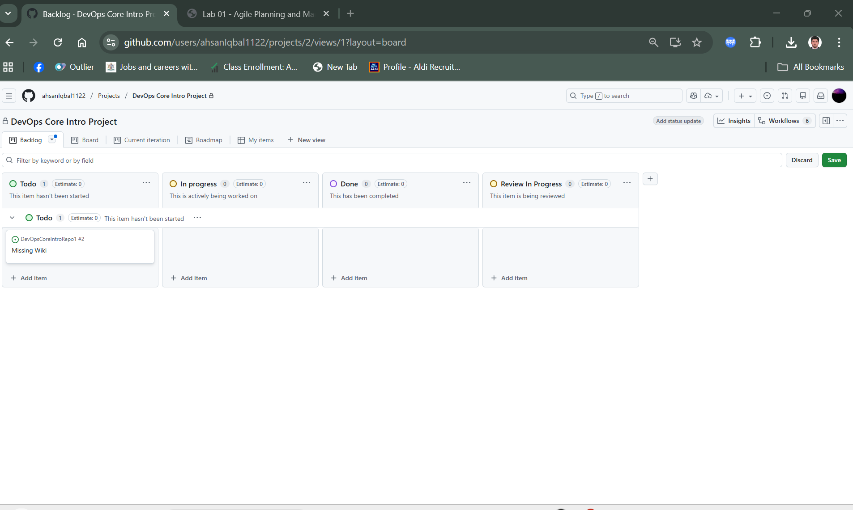

**Select missing wiki**

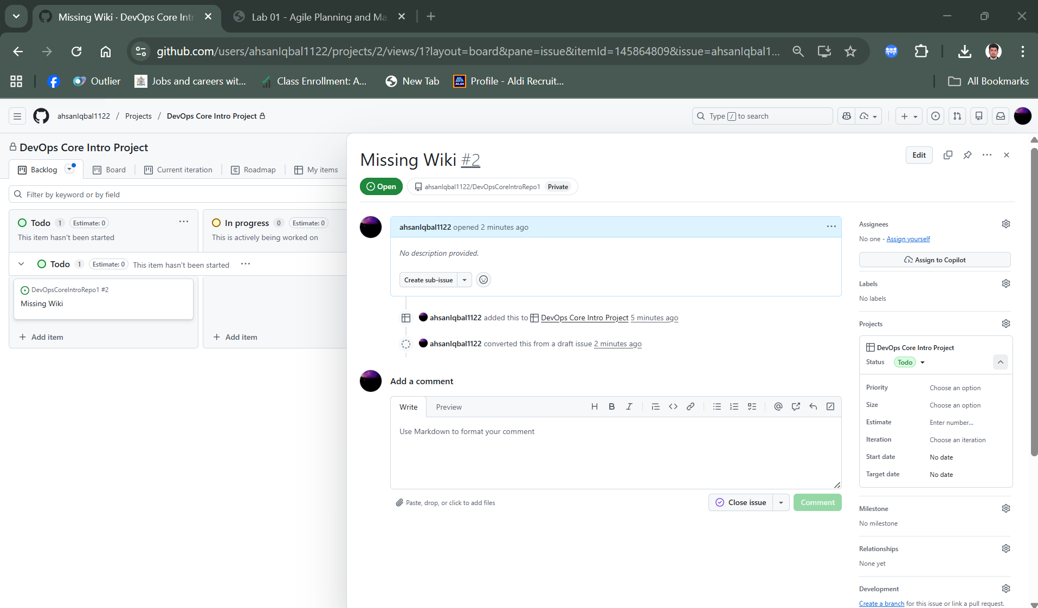

Add label and milestones

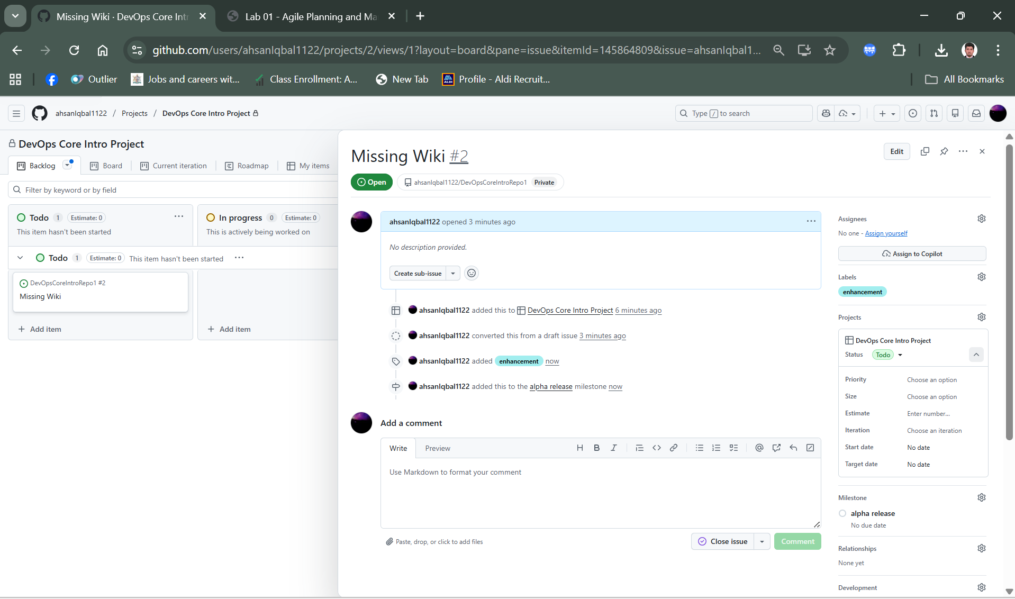

Add another item in todo

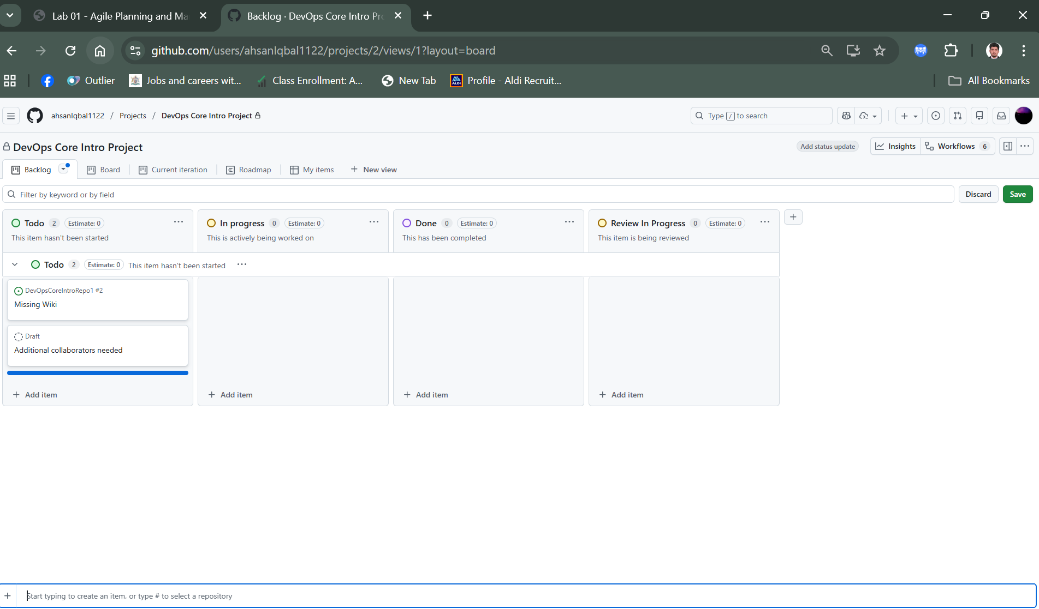

select **Convert to issue** and select **DevOpsCoreIntroRepo** to add the item to the repo.

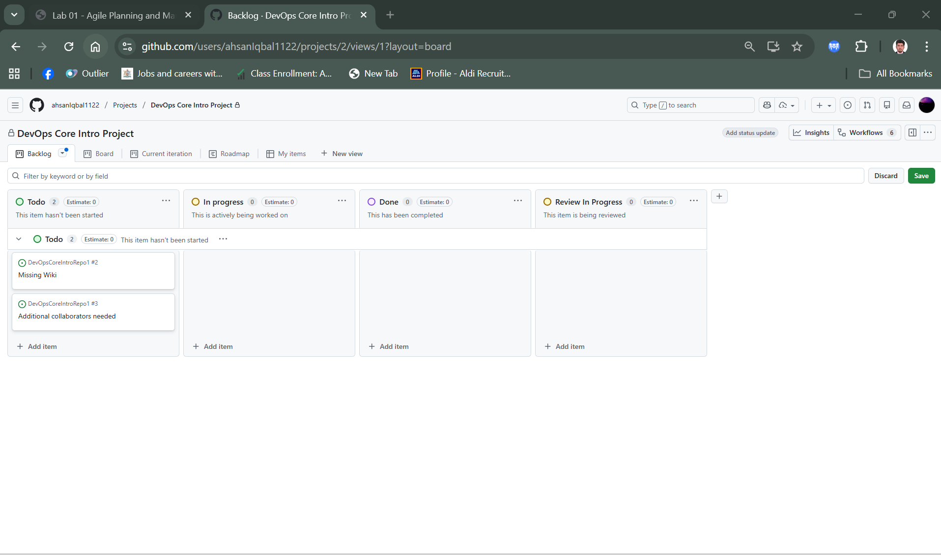

**Task 2: Add an item based on an issue**

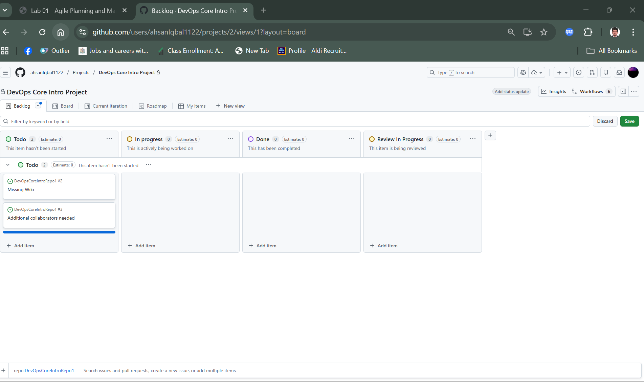

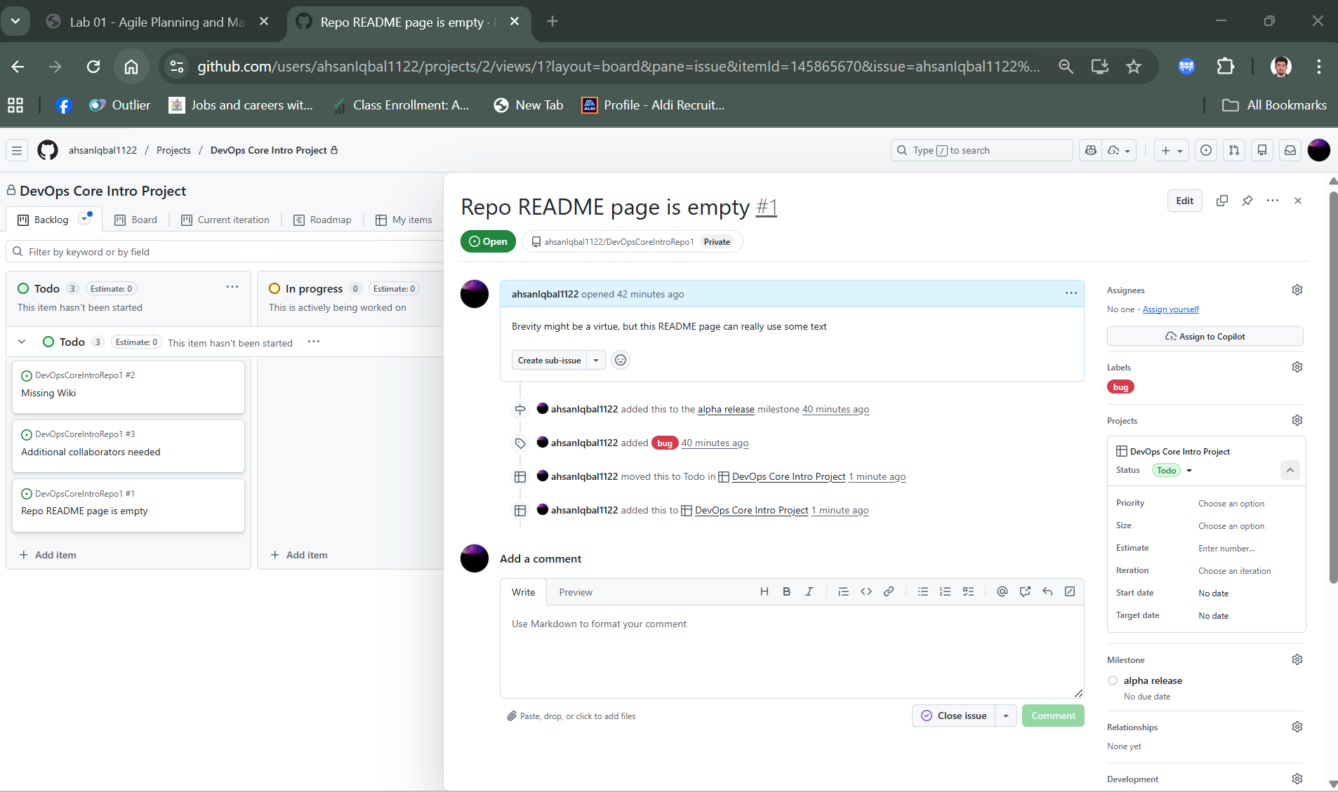

**Select Assignees**

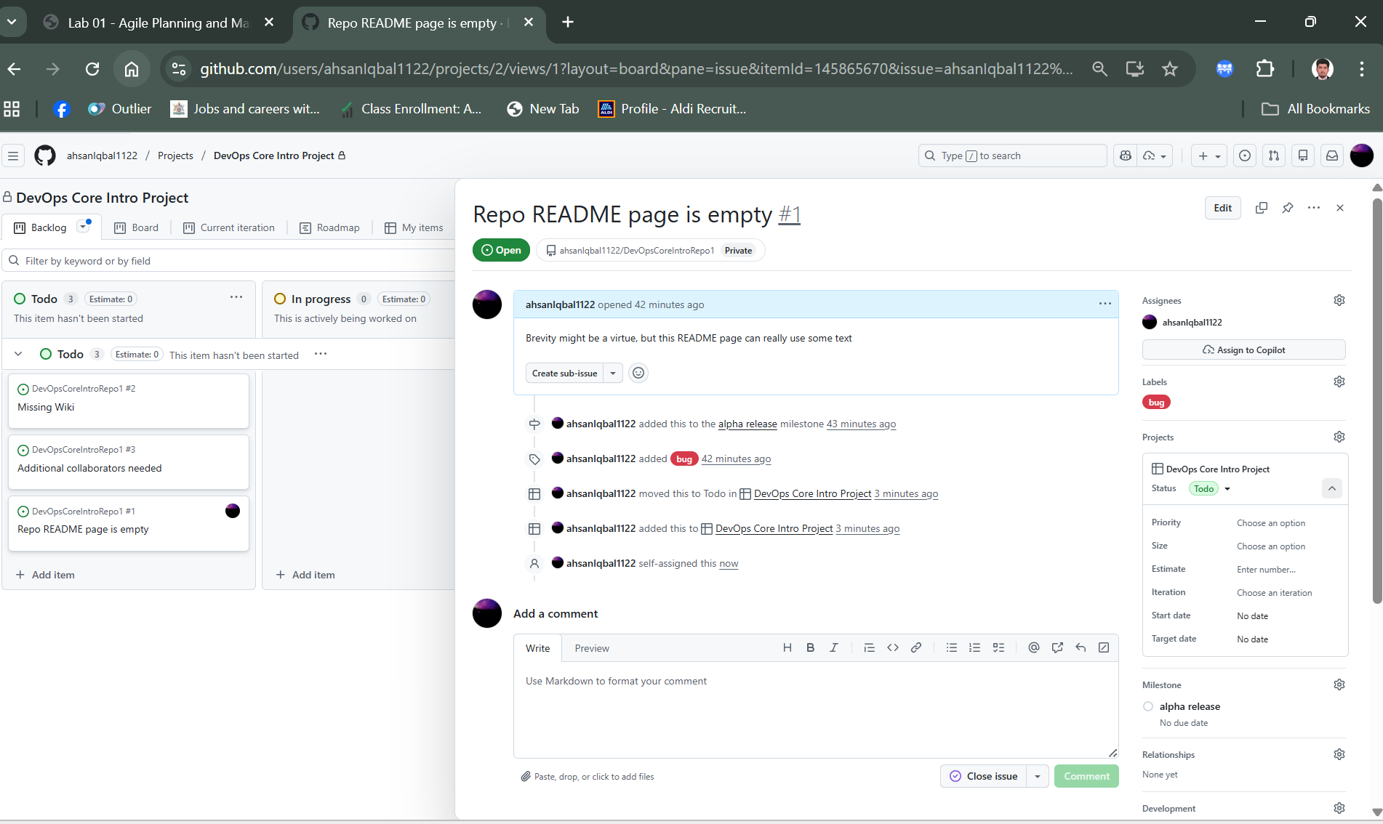

**Drag the Repo README page is empty item from the Todo column and drop it in the In Progress column.**

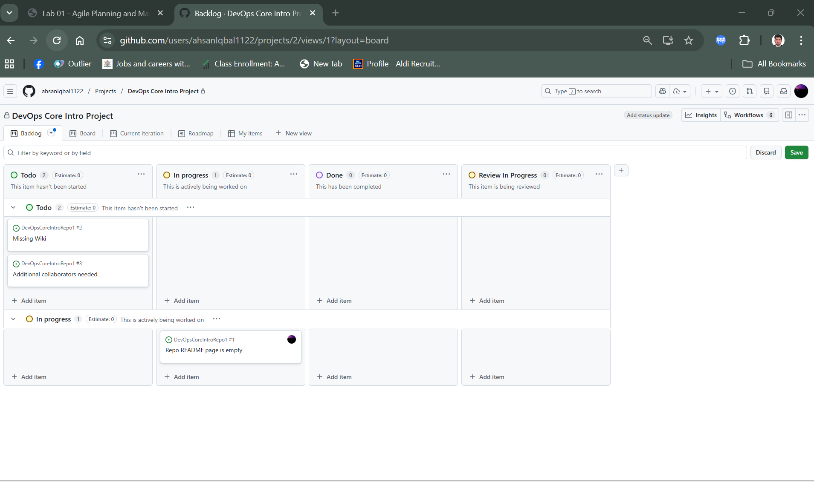

**Task 3: Review automation settings**

**Workflows**

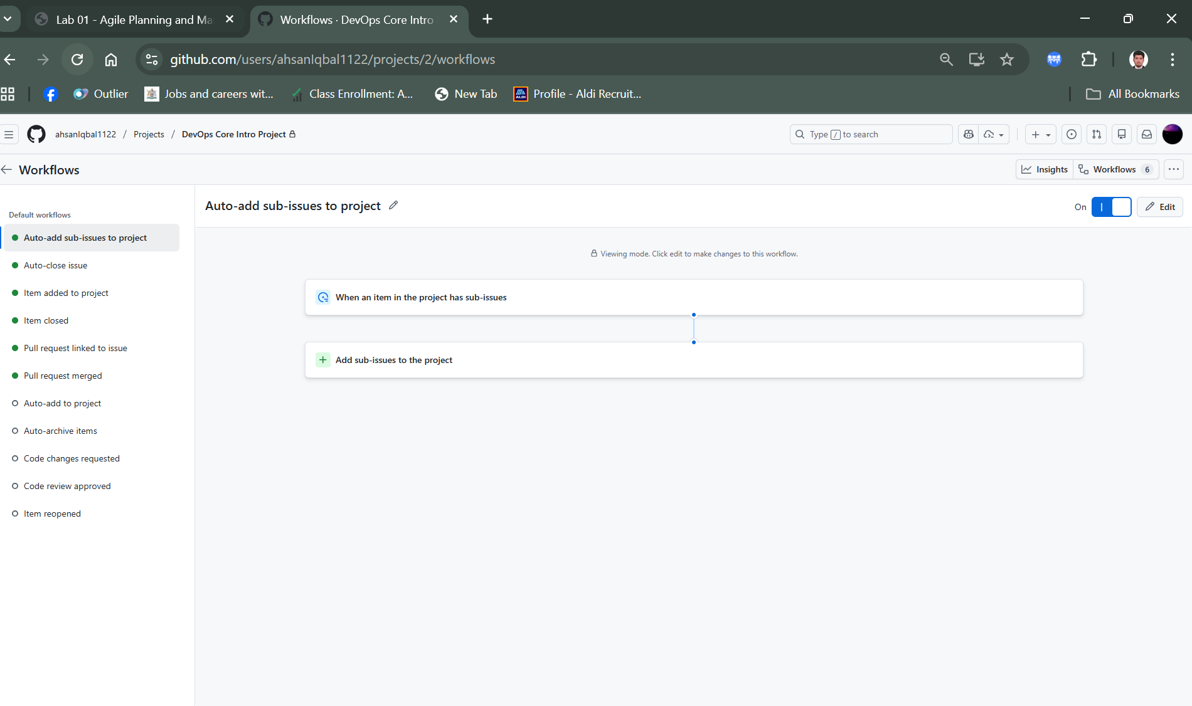

**Item is closed and status done**

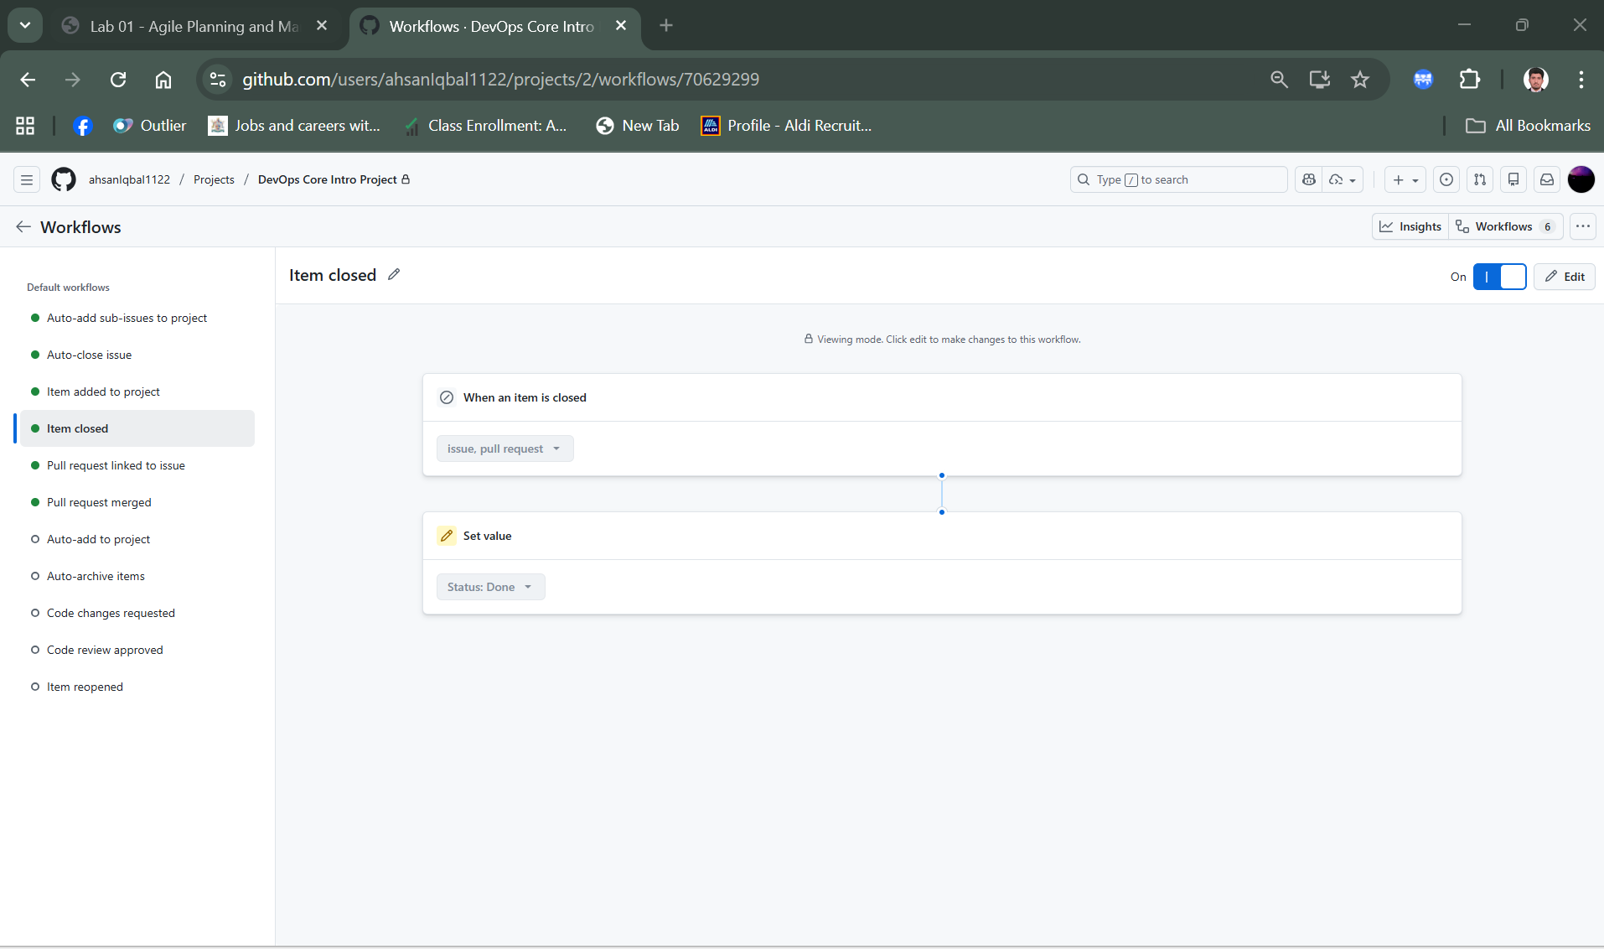

**Select repo**

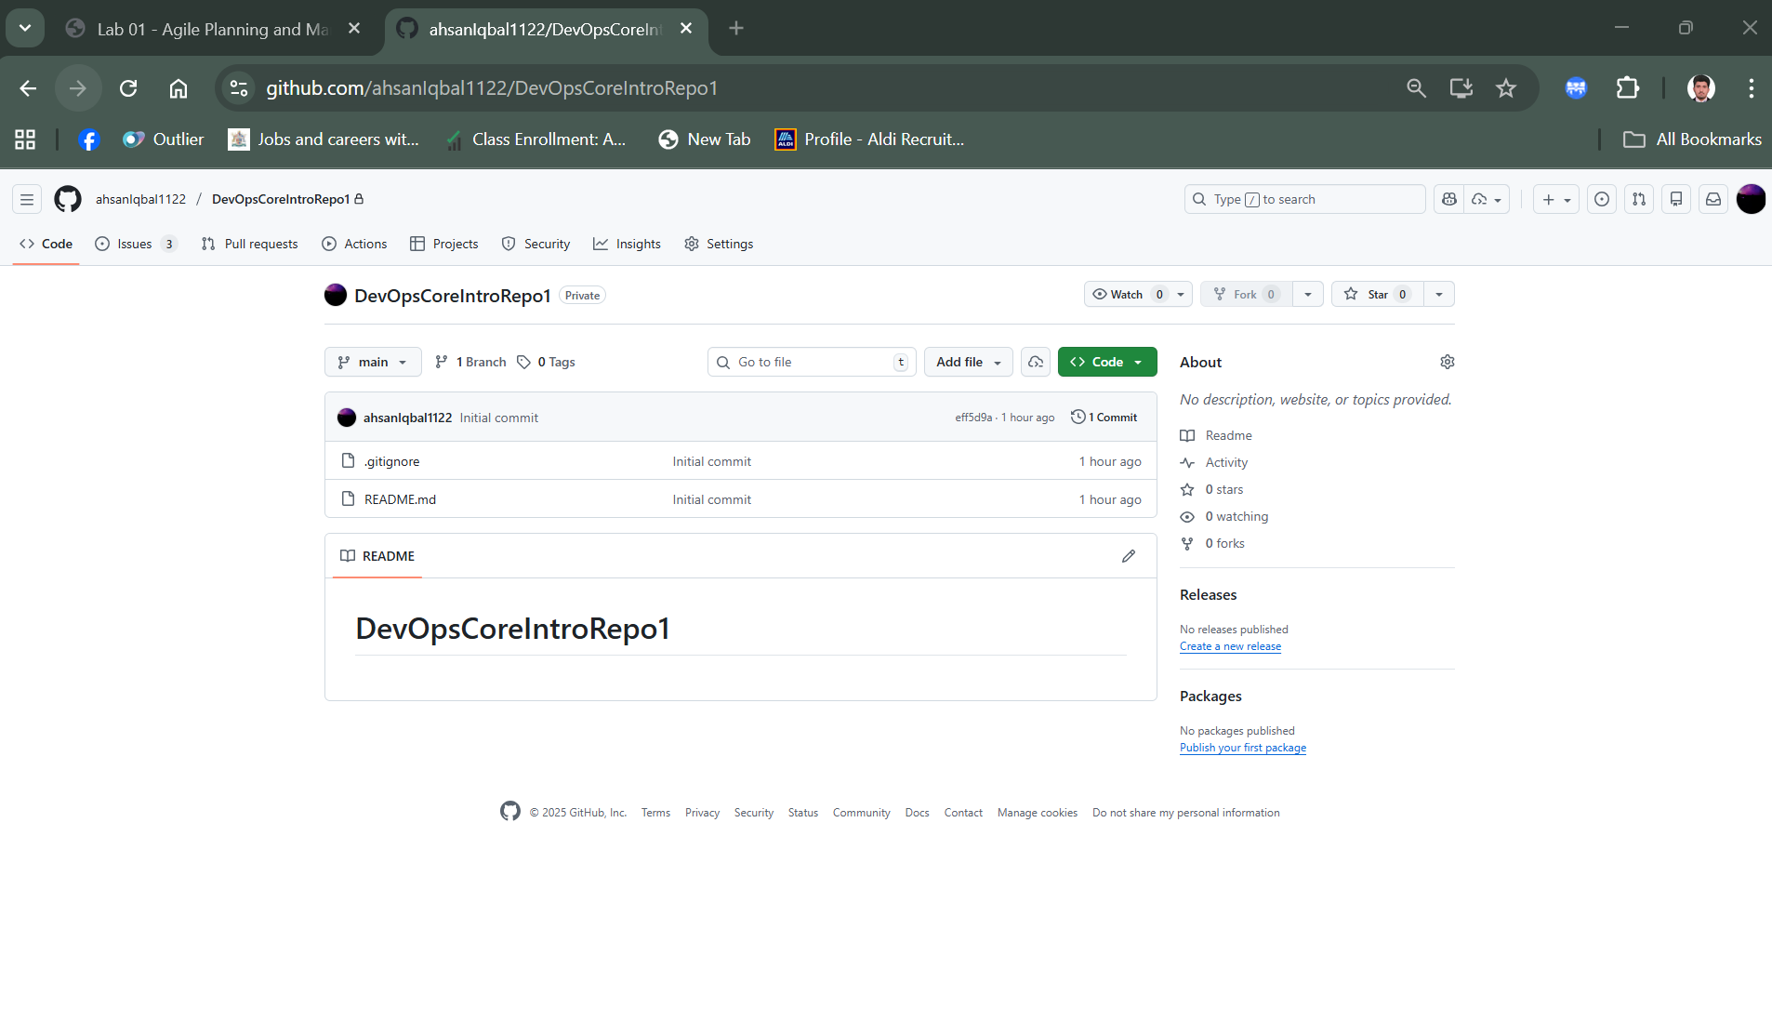

**Commit the change in the readme file**

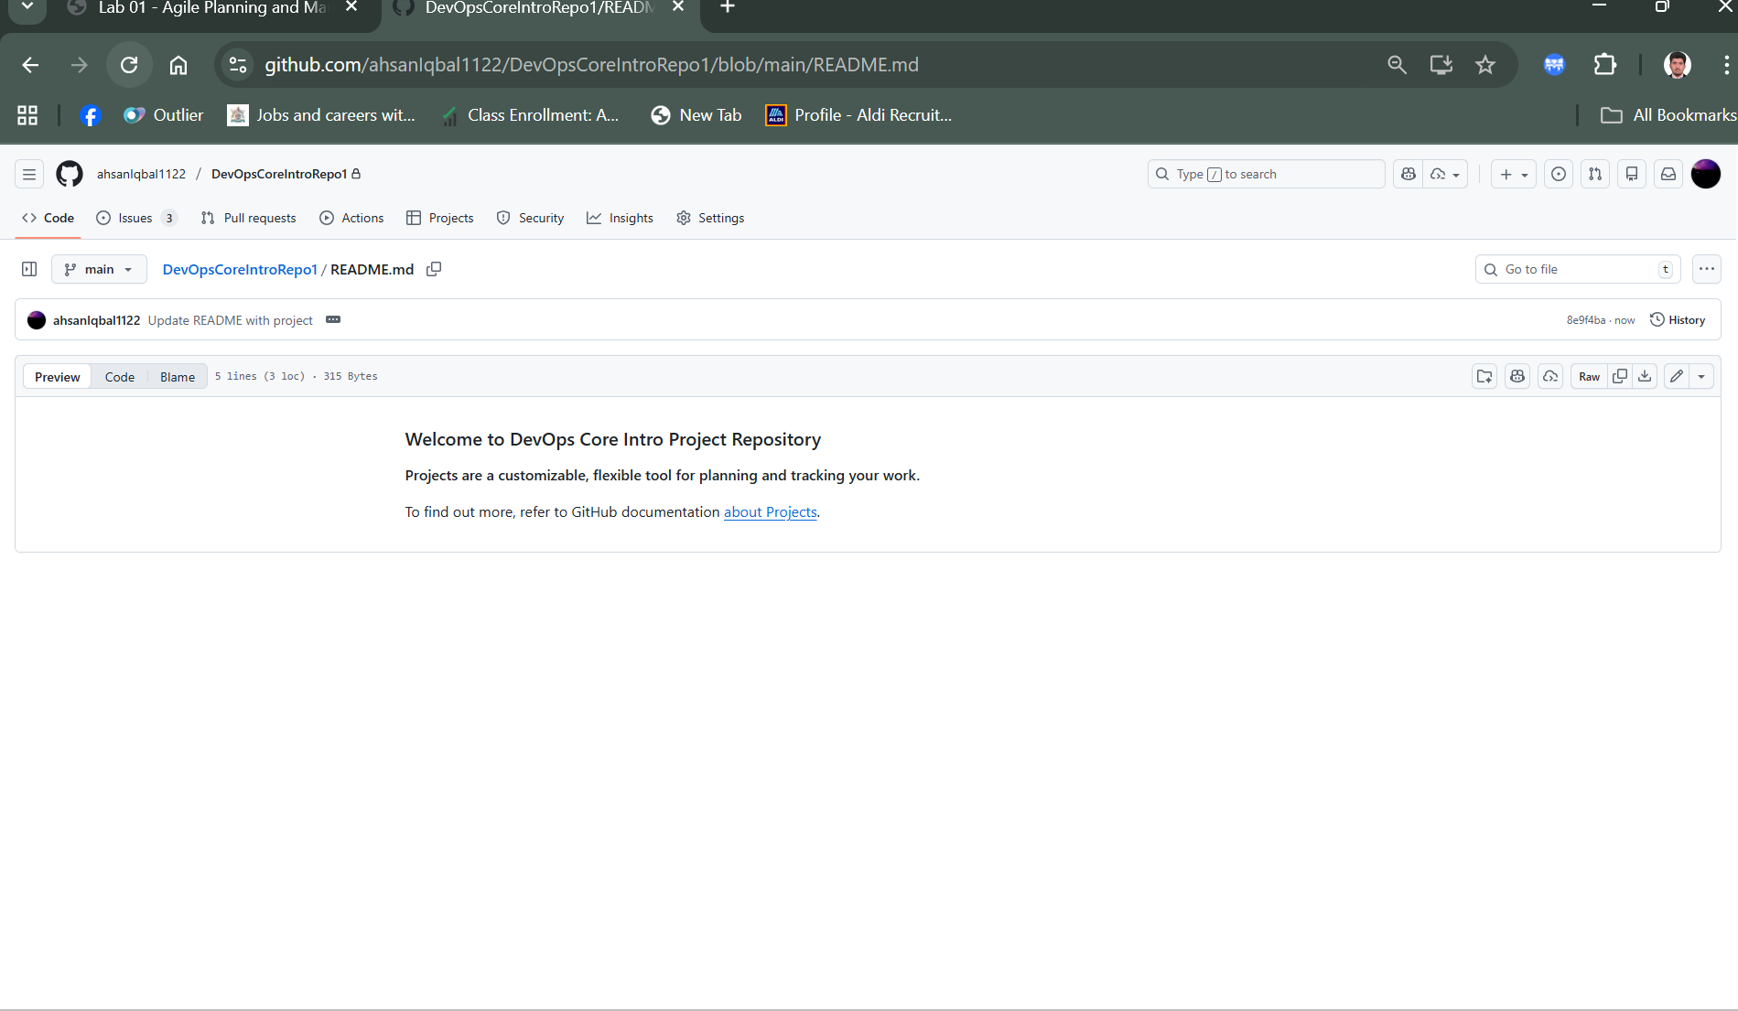

**Issue Tab**

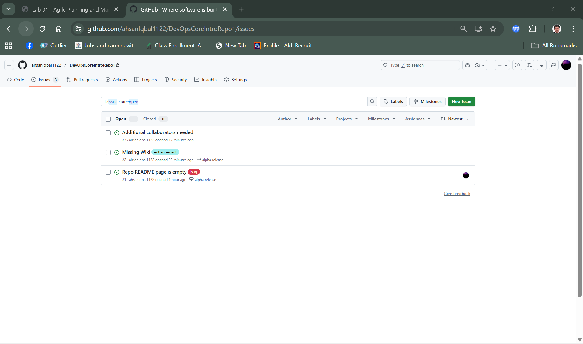

**Readme page empty is marked as completed**

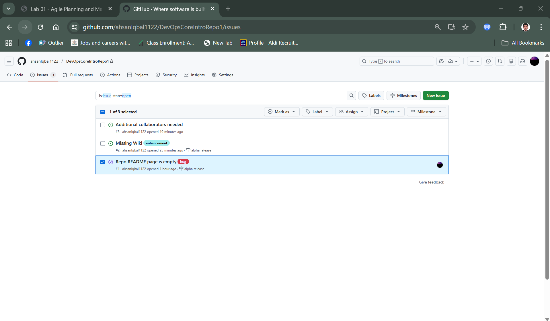

**In the project it’s marked as done**

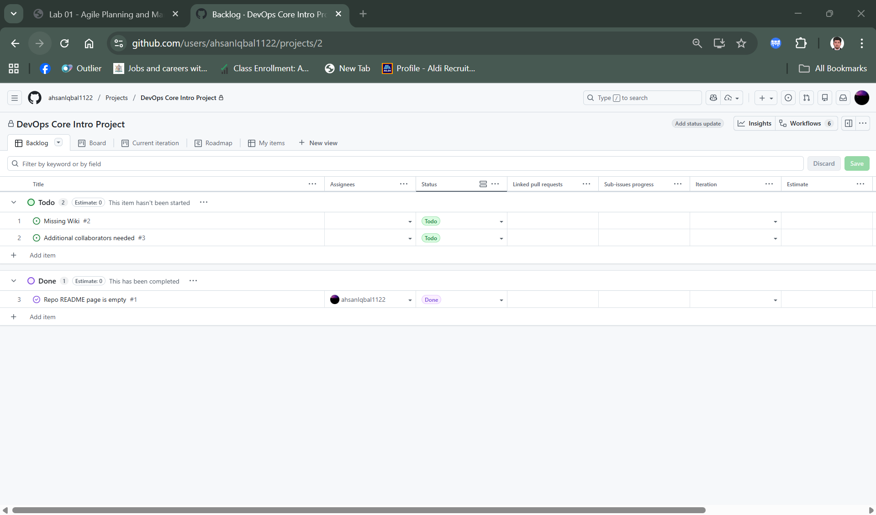

**Lab 02 - Implement Flow of Work with GitHub**

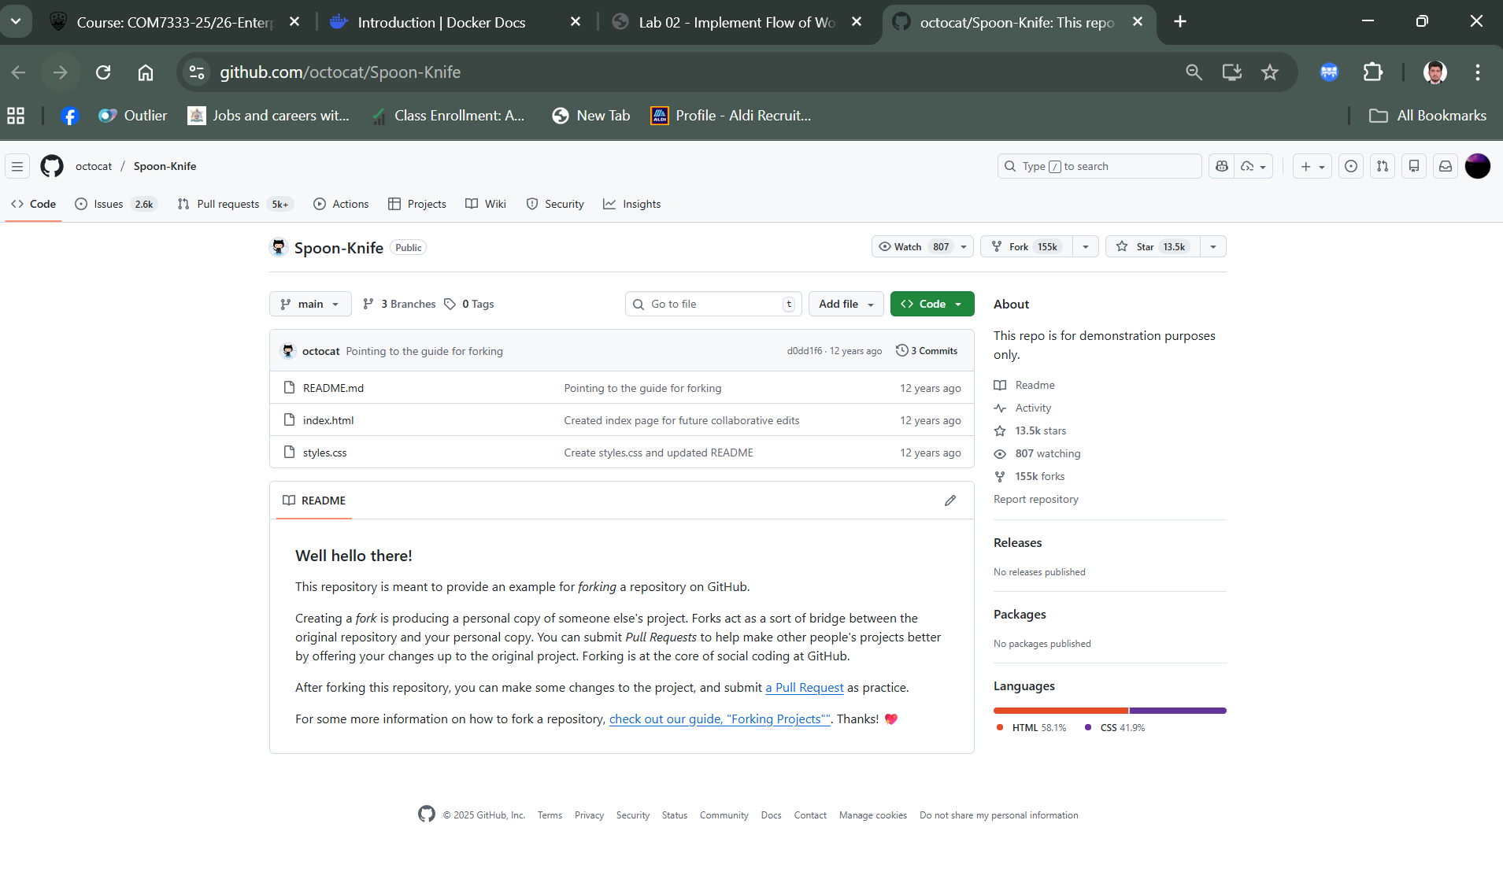

**Create a new fork**

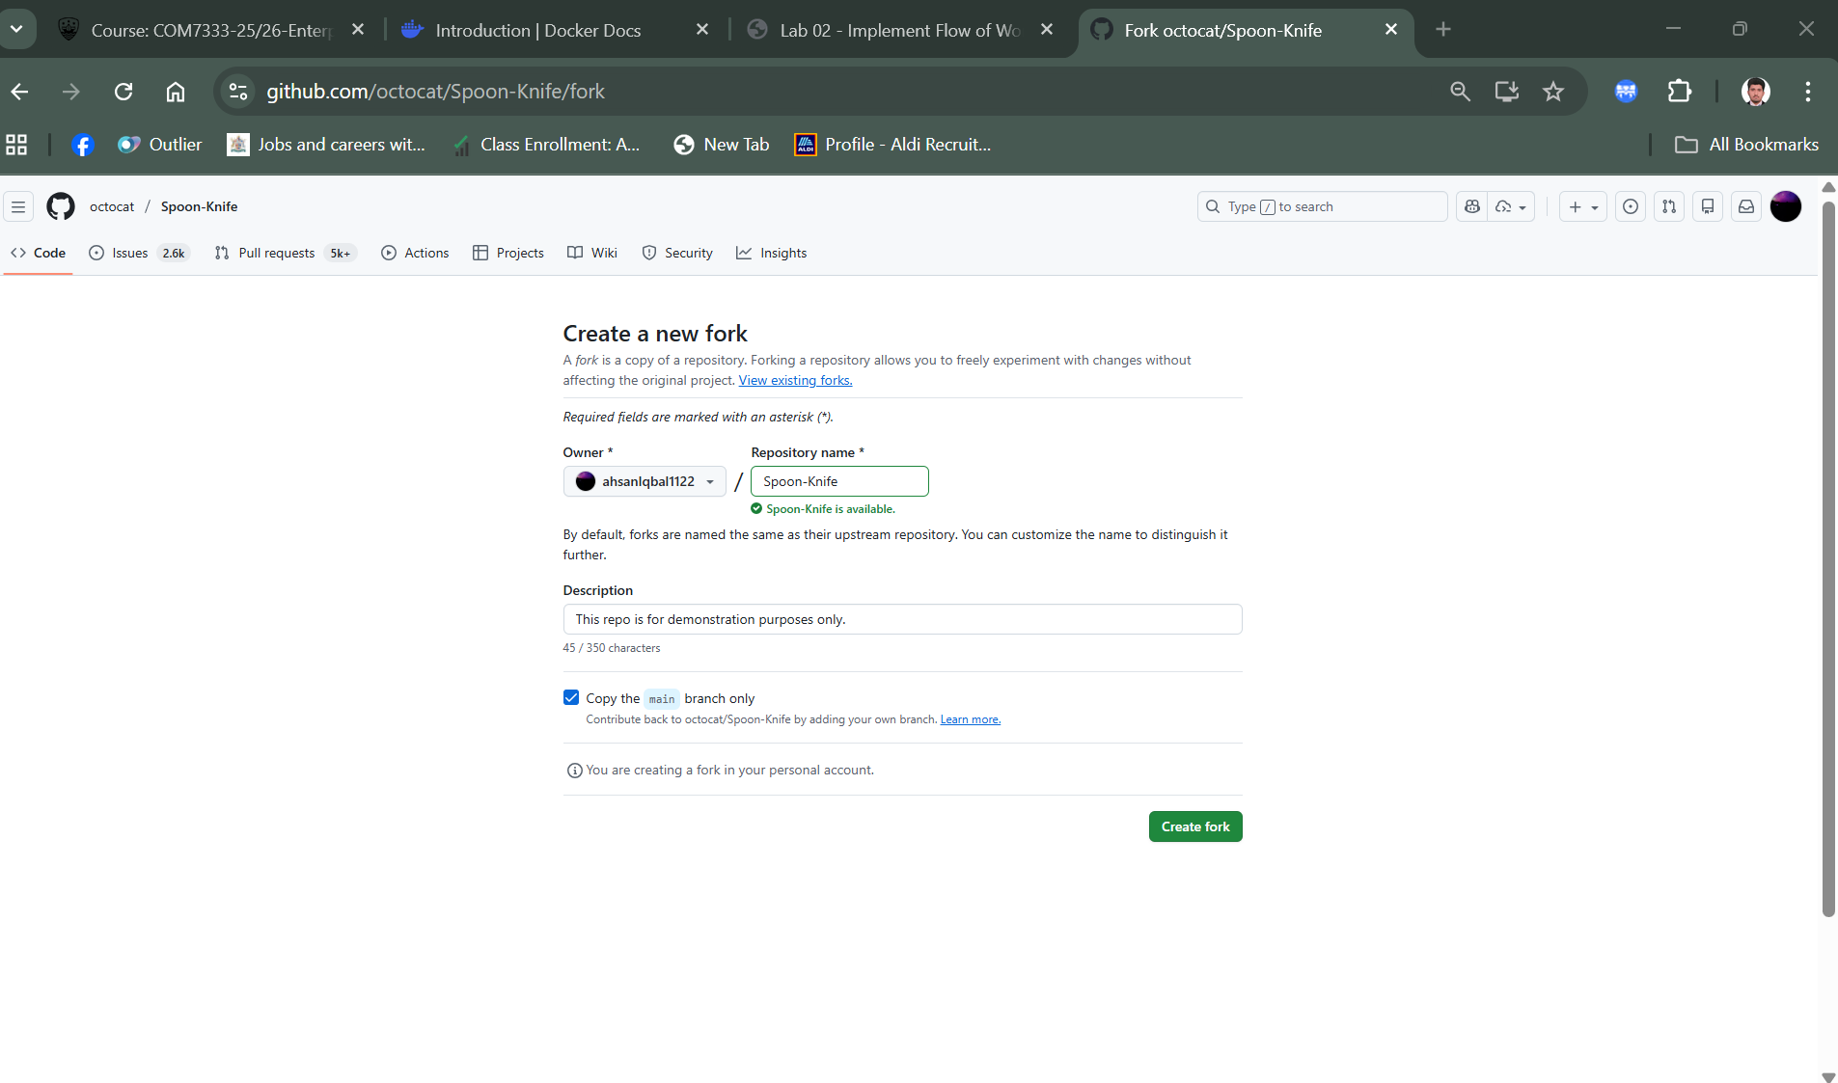

**Task 2: Configure a GitHub repo**

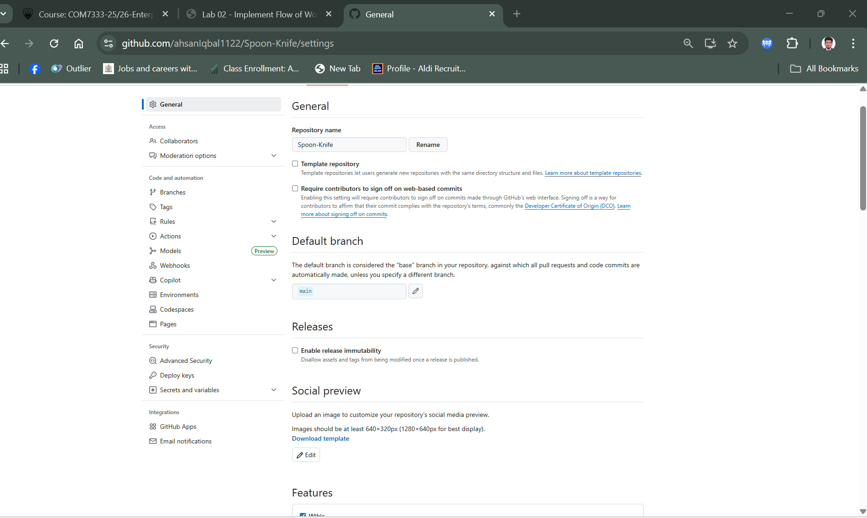

**Enable the issue checkbox**

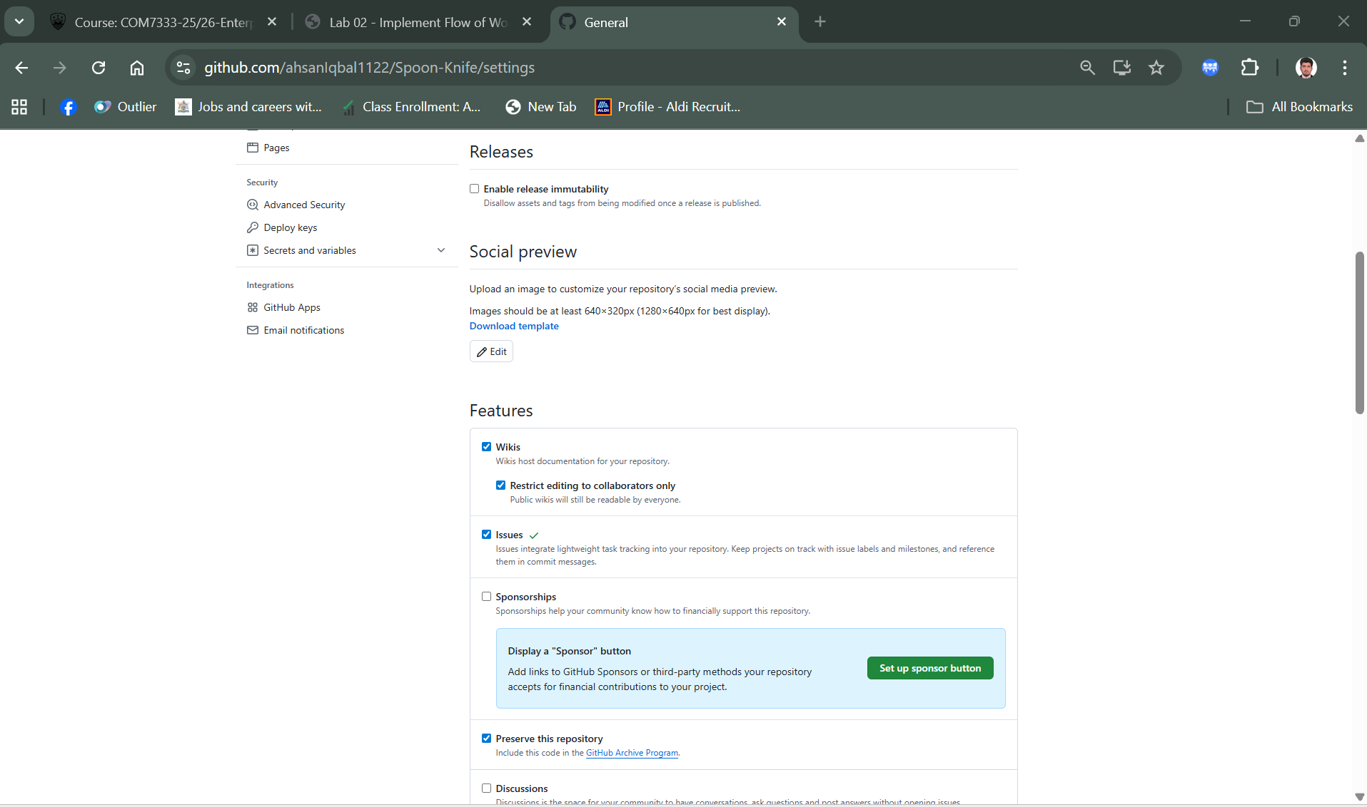

**Pages**

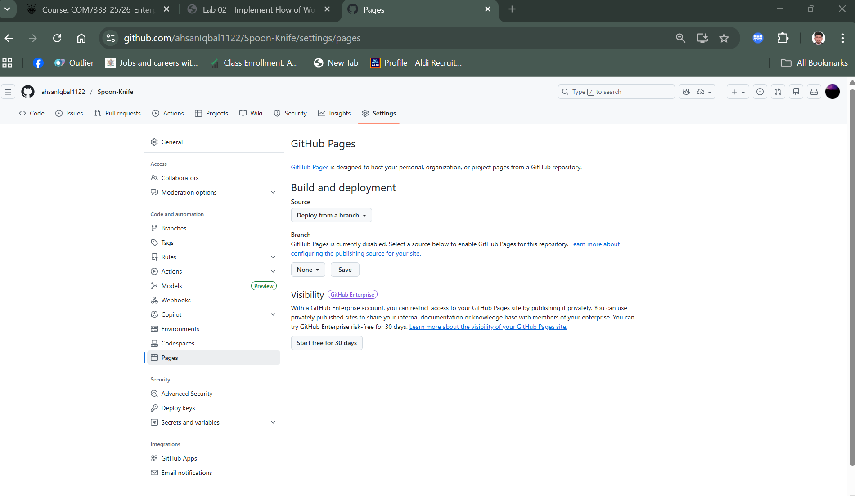

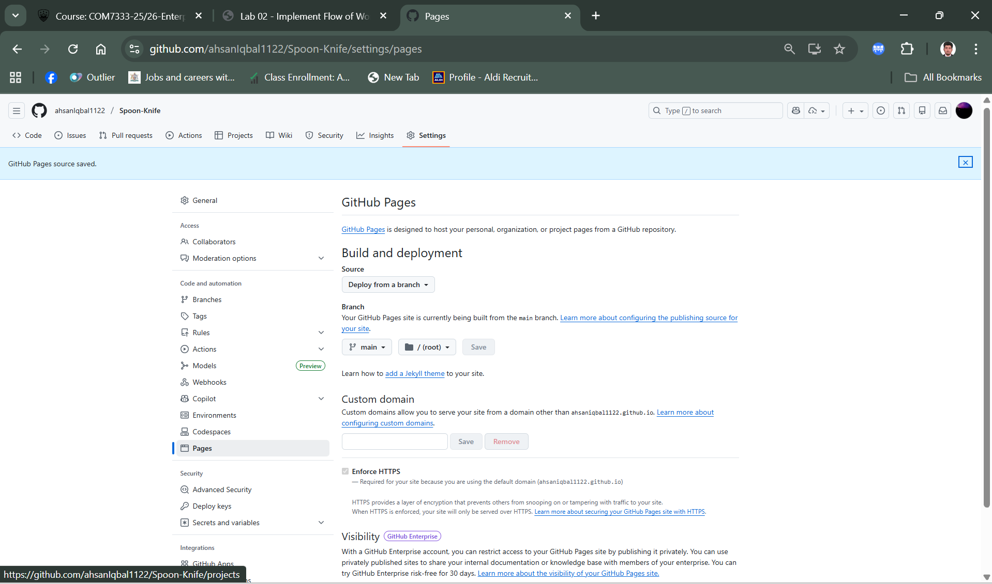

**Visit fork website**

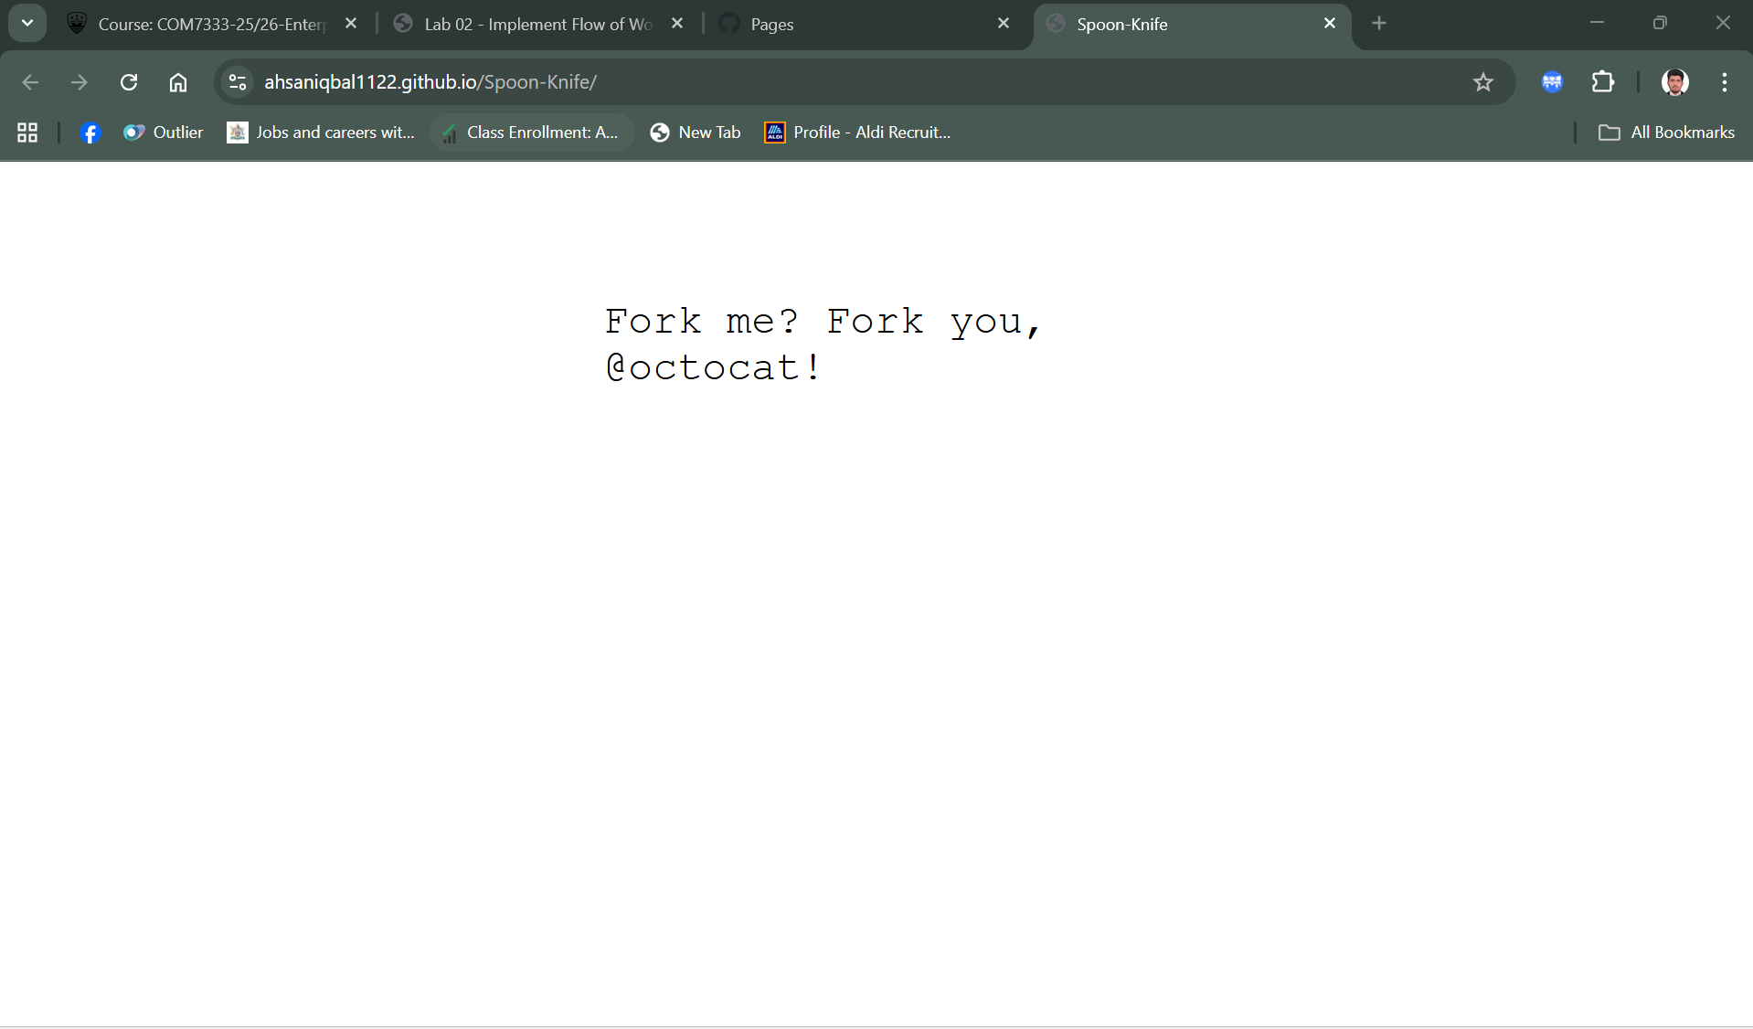

**Link this with pervious lab project**

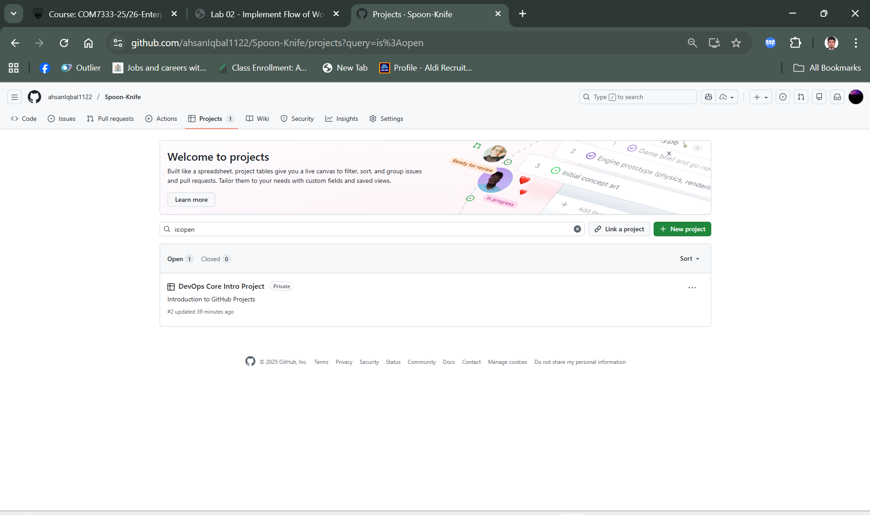

**Task 3: Create an issue**

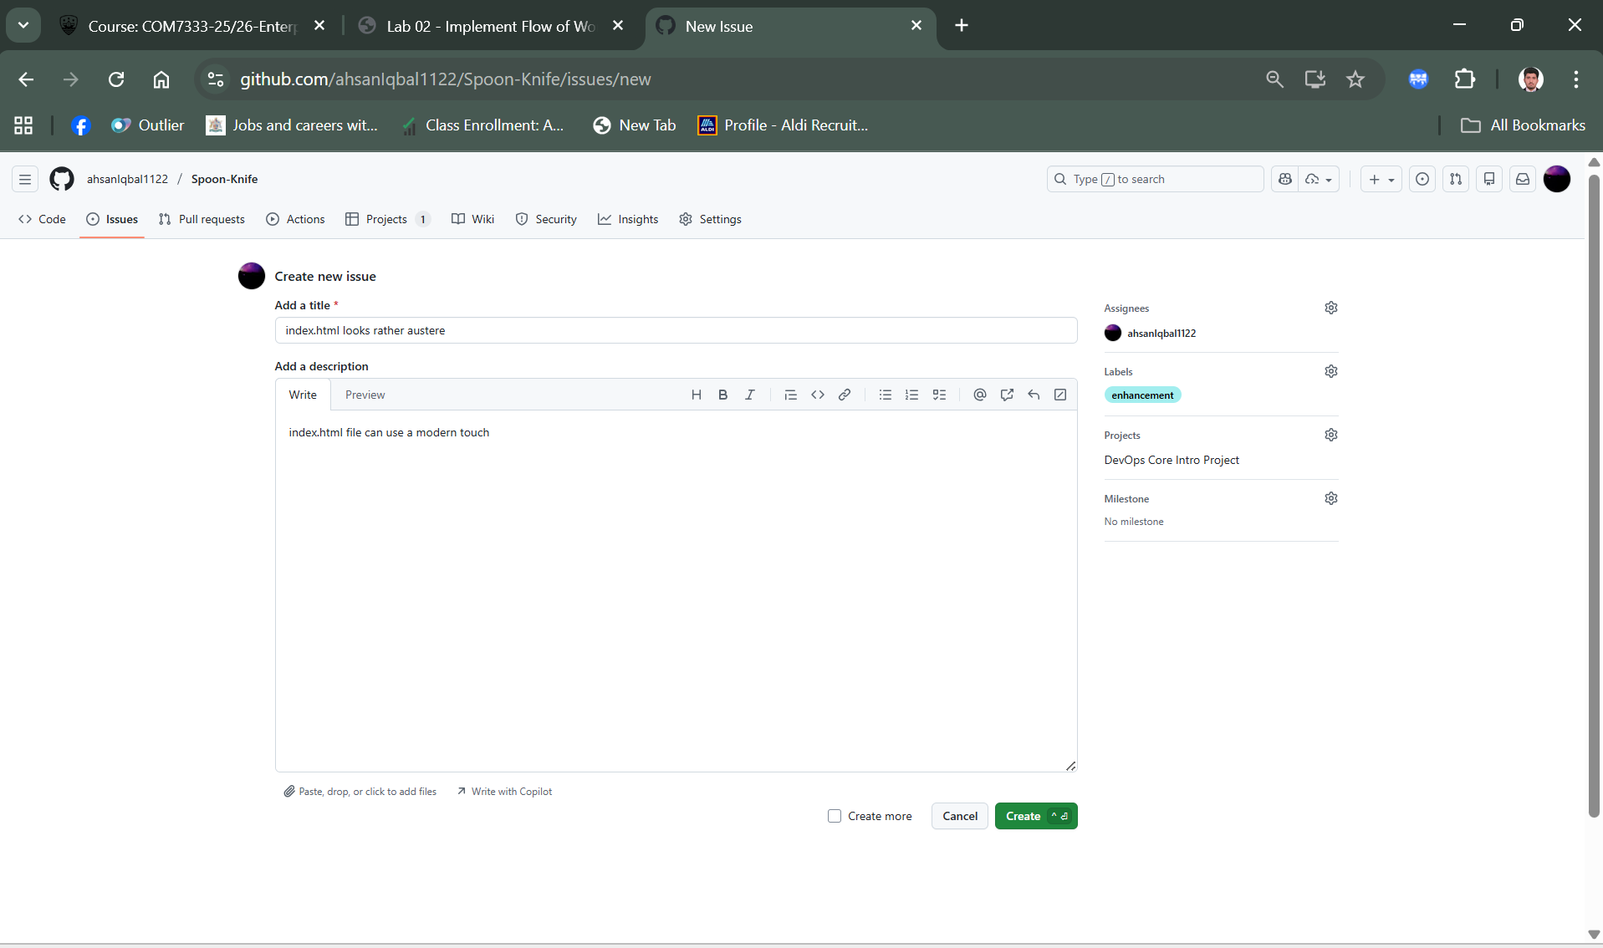

**Recent issue status in progresss**

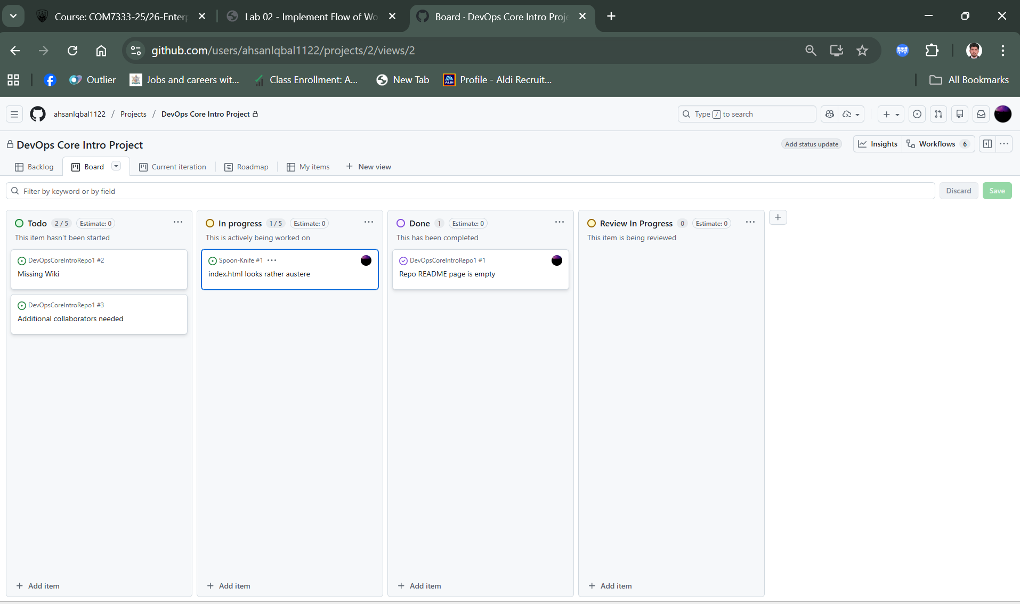

**Task 4: Create a branch**

**Create branch: update index.html from ‘main’ entry to create a new branch.**

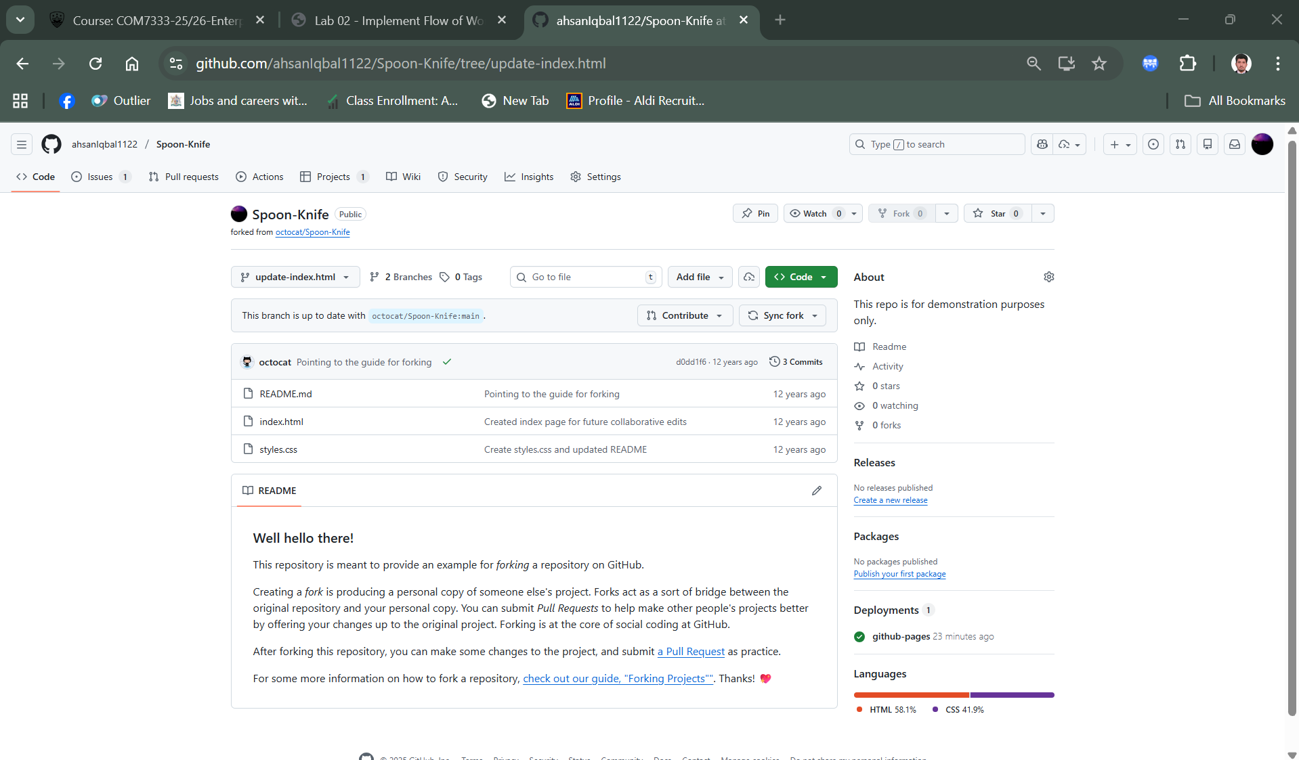

**Task 5: Update files in the branch**

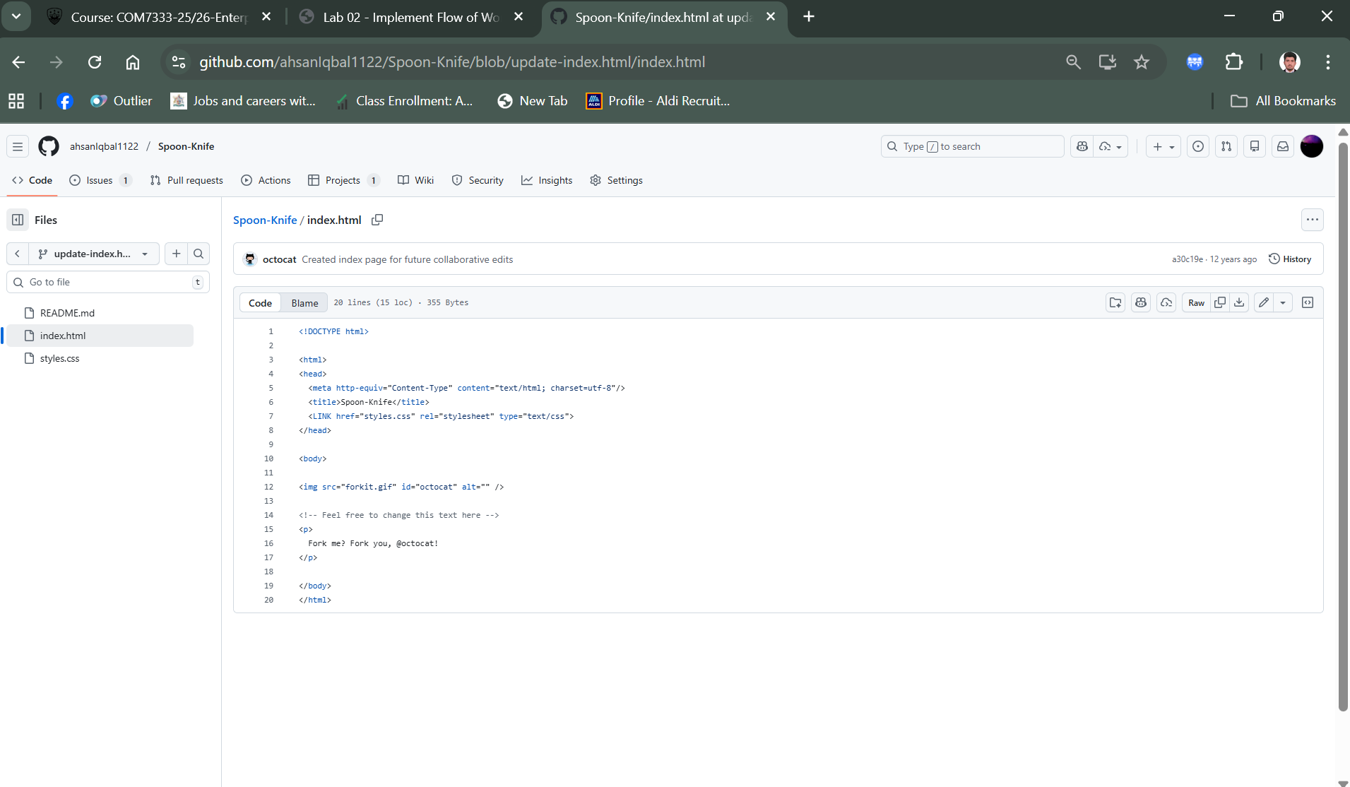

**Commit change in index.html file**

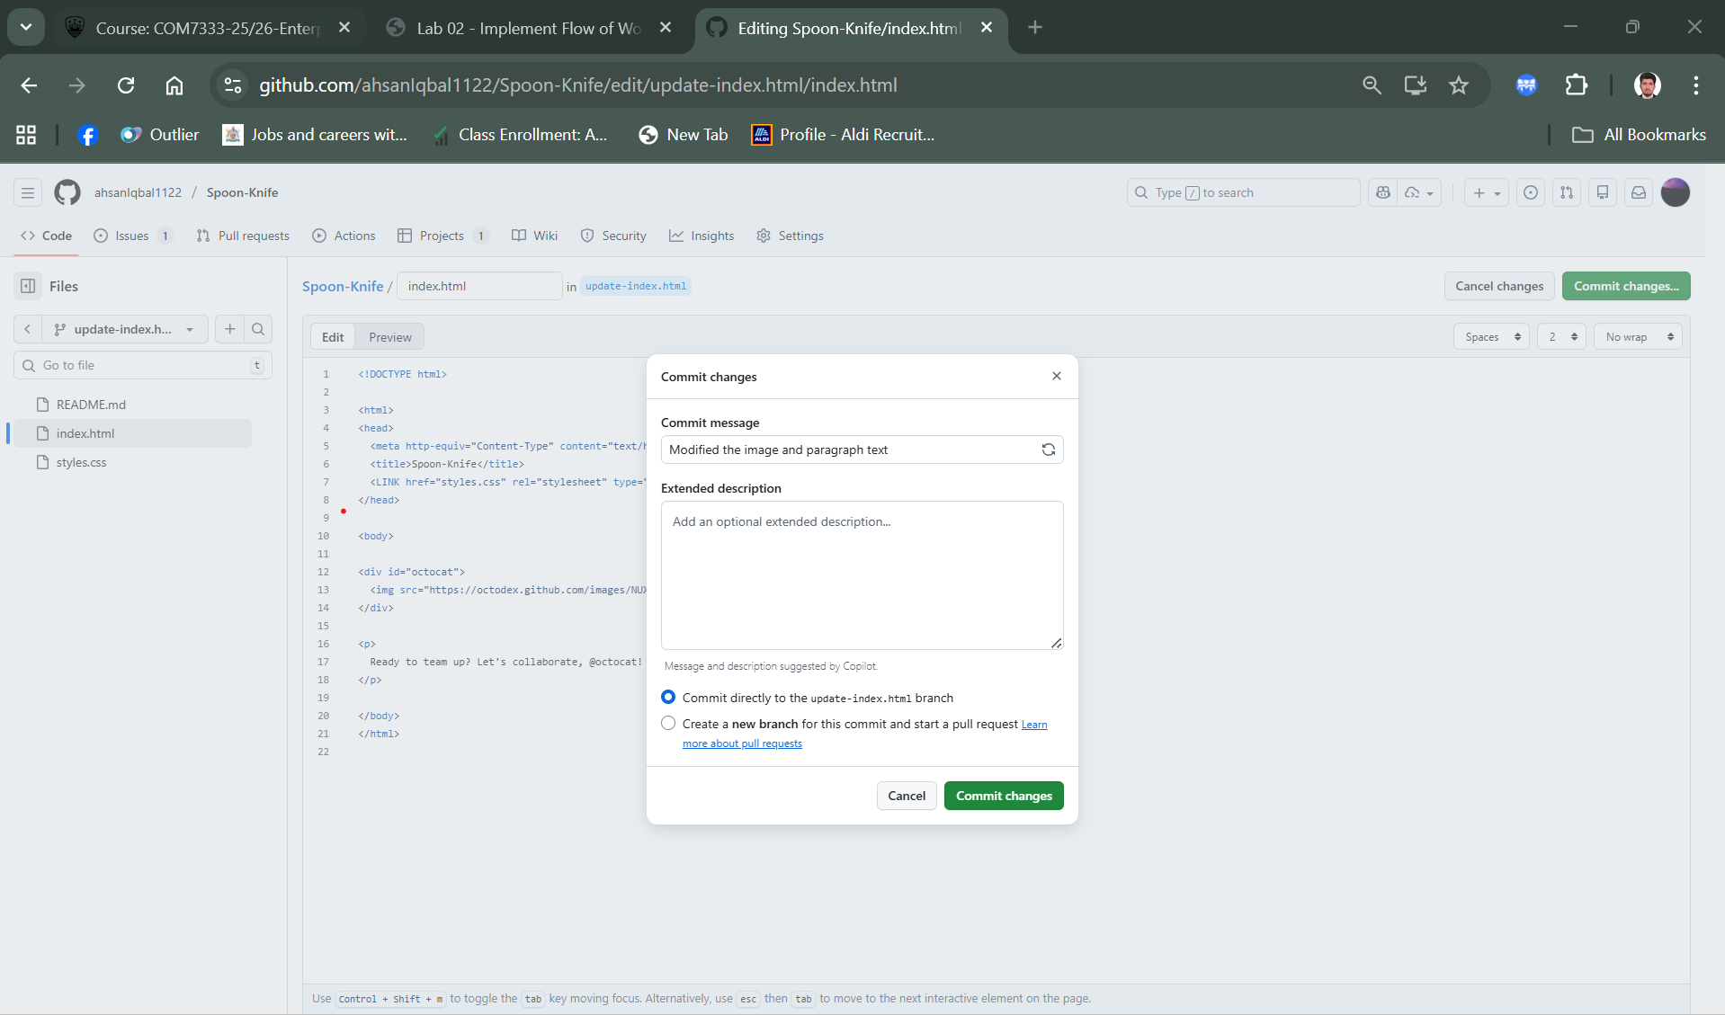

**Commit changes in style.css file**

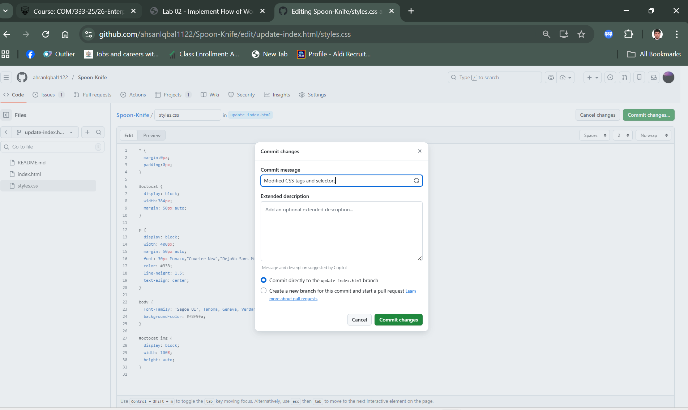

**Task 6: Create and merge a pull request**

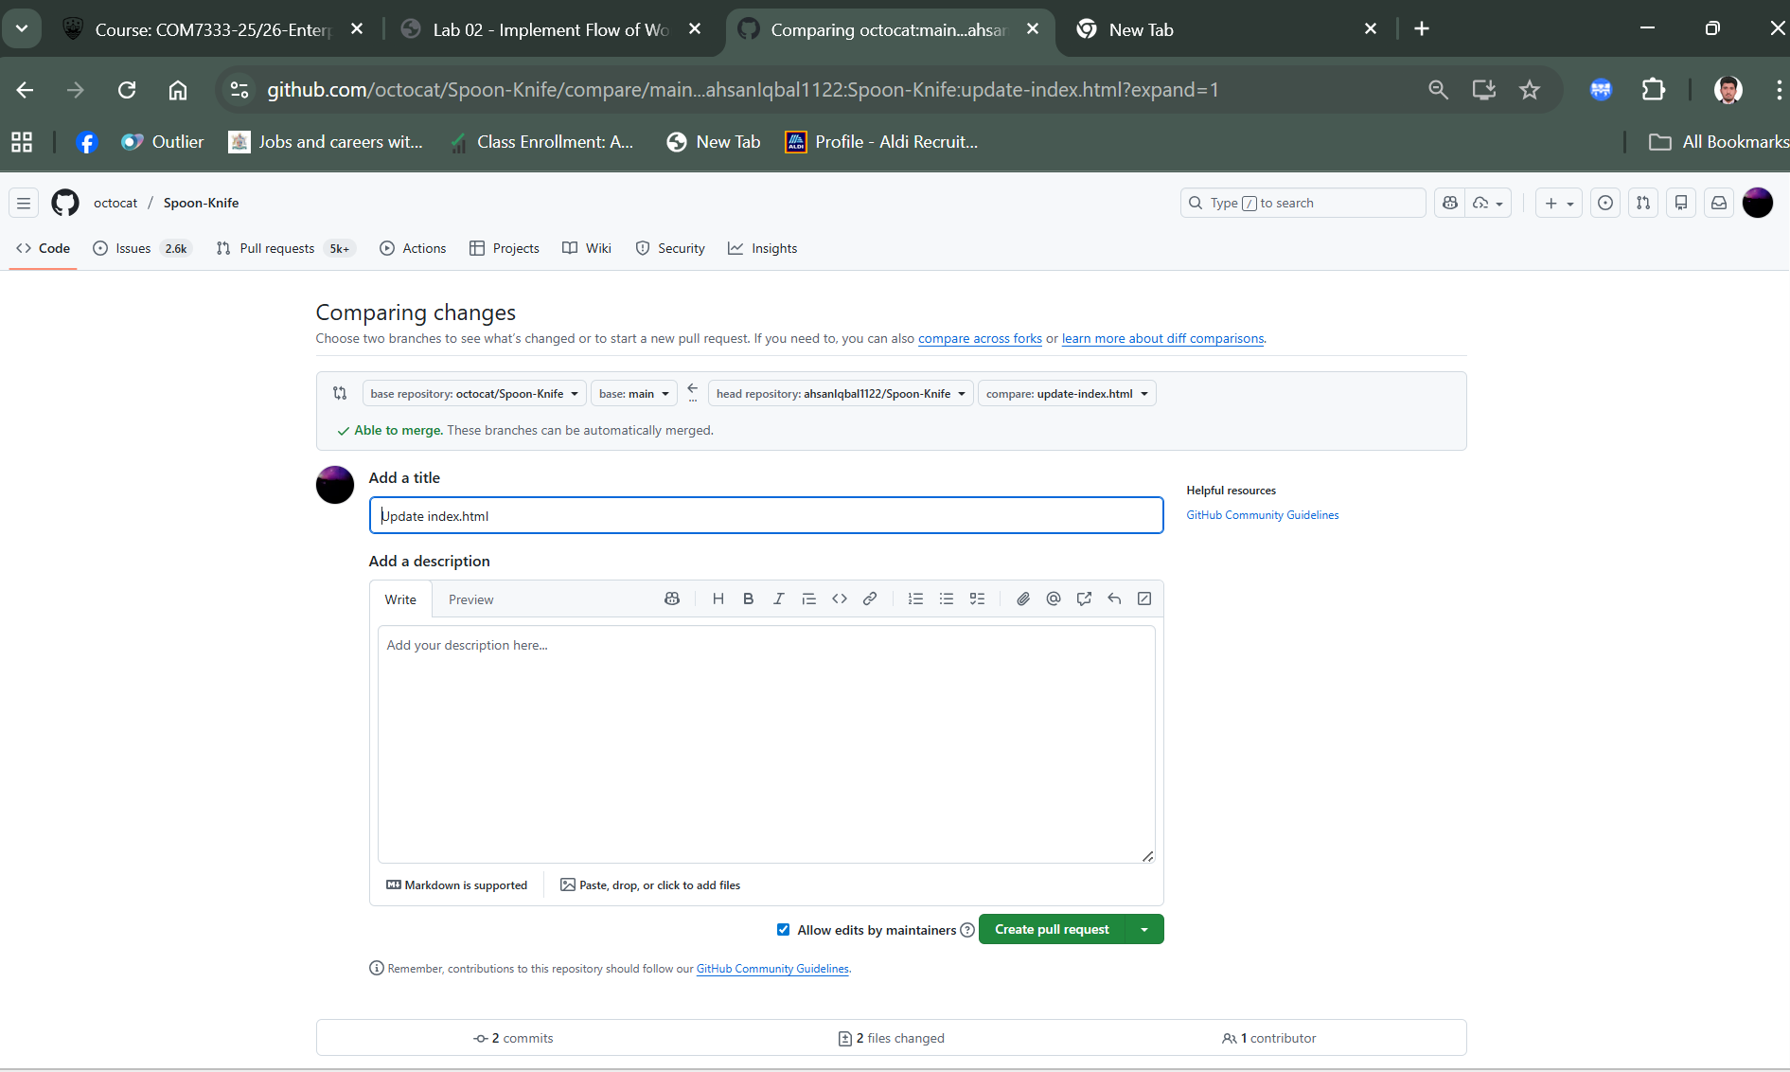

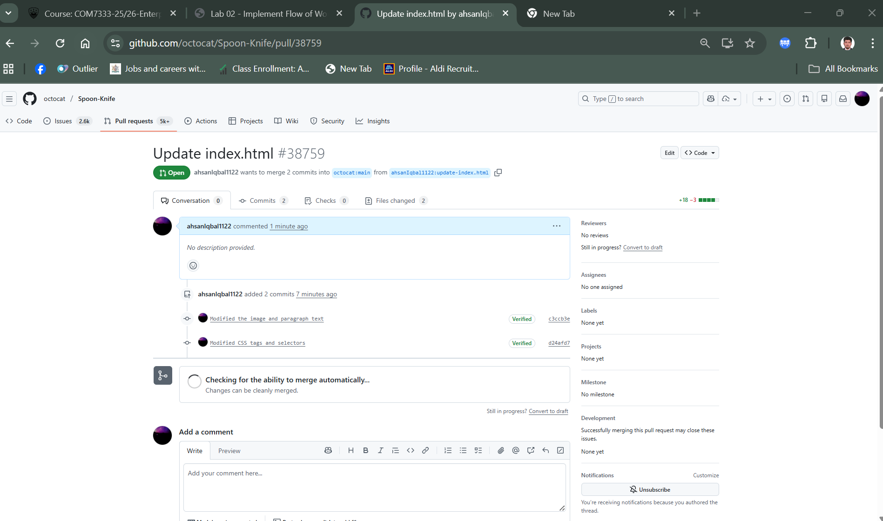

**Task 7: Close the issue**

**Mark as completed**

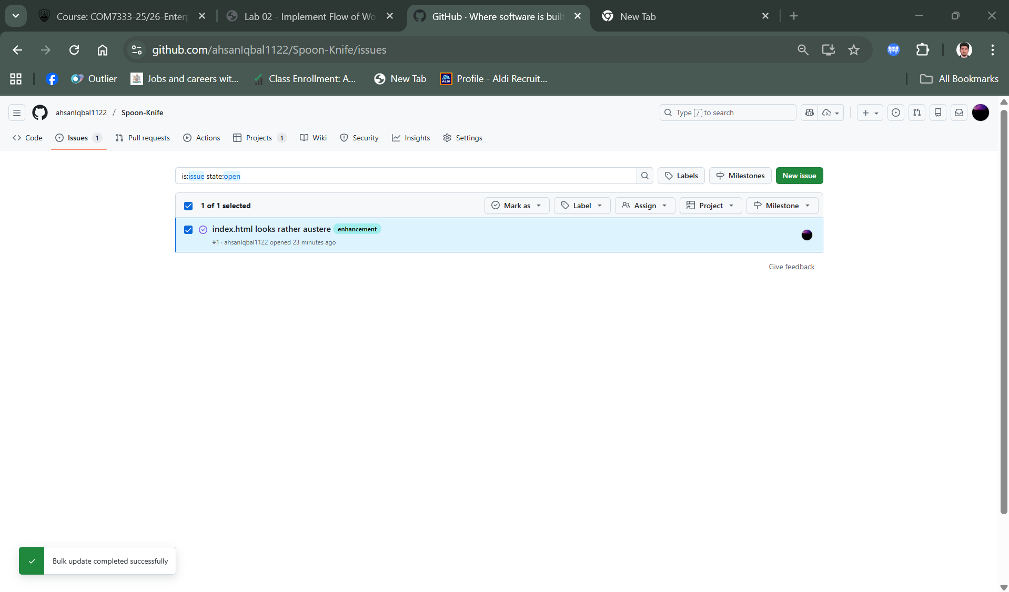

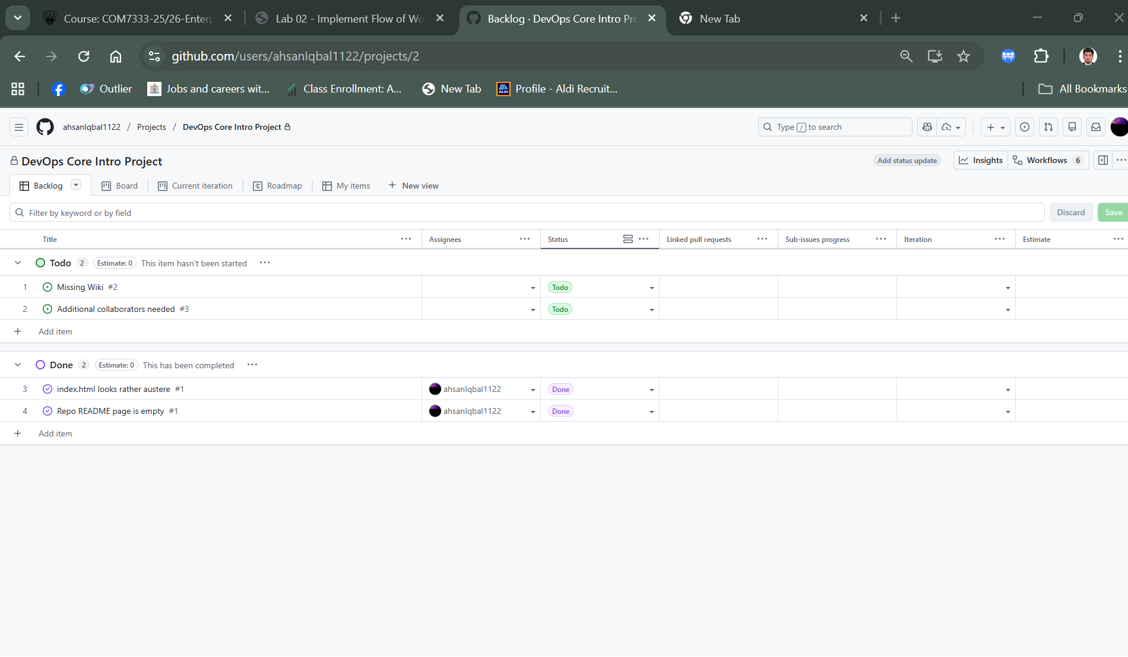

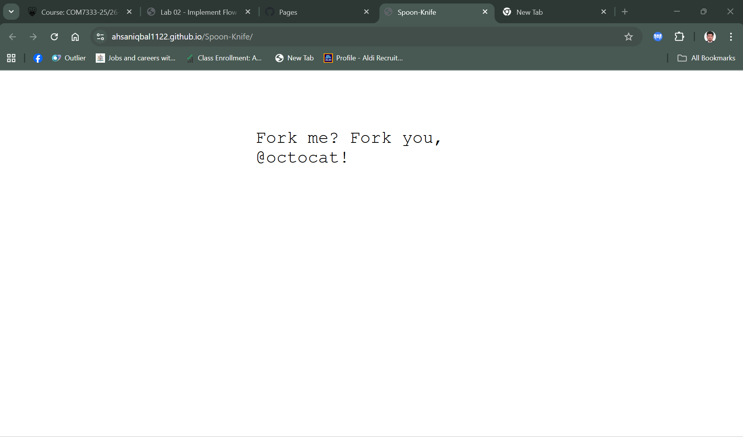

**NOTE**

**LAB 3 and 4 cannot complete because of the subscription issue**

**GITHUB LINKS**

[**https://github.com/ahsanIqbal1122/DevOpsCoreIntroRepo1**](https://github.com/ahsanIqbal1122/DevOpsCoreIntroRepo1)

[**https://github.com/ahsanIqbal1122/Spoon-Knife**](https://github.com/ahsanIqbal1122/Spoon-Knife)

[**https://github.com/users/ahsanIqbal1122/projects/2**](https://github.com/users/ahsanIqbal1122/projects/2)